MES Abasaheb Garware College (Autonomous), Pune
S.Y.B.Sc. (Data Science) – Semester III
DTS-202-M: Database Management System

ASSIGNMENT NO. 12
MINI PROJECT
TRAINING INSTITUTE
MANAGEMENT SYSTEM

Name | Anushka Pachpute
Roll No.
Division | S.Y.B.sc Data Science
Academic Year | 2026–2027
Course Subject | Database Management System
Semester | III

1. Objective
Develop a basic MySQL Training Institute Management System to manage students, trainers, courses, batches, enrollments, attendance, and assessment results. The project demonstrates database planning, table relationships, query writing, business analysis, and presentation of findings.

2. Requirement Analysis and Project Planning
- A training institute offers courses; each course runs in one or more batches, and every batch has one trainer, dates and a timing.
- Main users: Administrator (students, trainers, courses, enrollments), Trainer (attendance and assessment results) and Institute Coordinator (batches and reports).
- Information stored: student, trainer, course and batch details, who joined which batch, session attendance, and test scores.
- Main reports: batch-wise students, course and trainer per batch, course-wise counts, low attendance, average scores, toppers, ranking and attendance comparison (Q1 to Q12).
- Sample data: a small Pune institute with 4 courses, 4 trainers, 6 batches, 15 students, 20 enrollments, 80 attendance records and 40 results.

3. Functional Requirements
- Maintain student details (name, date of birth, e-mail, phone, address, join date).
- Maintain course details such as duration and fees.
- Maintain trainer details and specialization.
- Create batches for courses and assign one trainer to each batch.
- Enroll students into batches and stop the same student joining the same batch twice.
- Record attendance (Present or Absent) for each enrollment and session.
- Record assessment results with score and maximum score for each enrollment.
- Reject any record that is not linked to a valid parent record.
- Generate reports for enrollment, attendance, performance and batch comparison.

4. ER Diagram
The ER diagram shows the seven required tables and six one-to-many relationships. Enrollment is drawn as an associative entity (dashed border) between Student and Batch, with its own attributes EnrollmentDate and Status. Primary keys are underlined and foreign keys are dashed ovals.
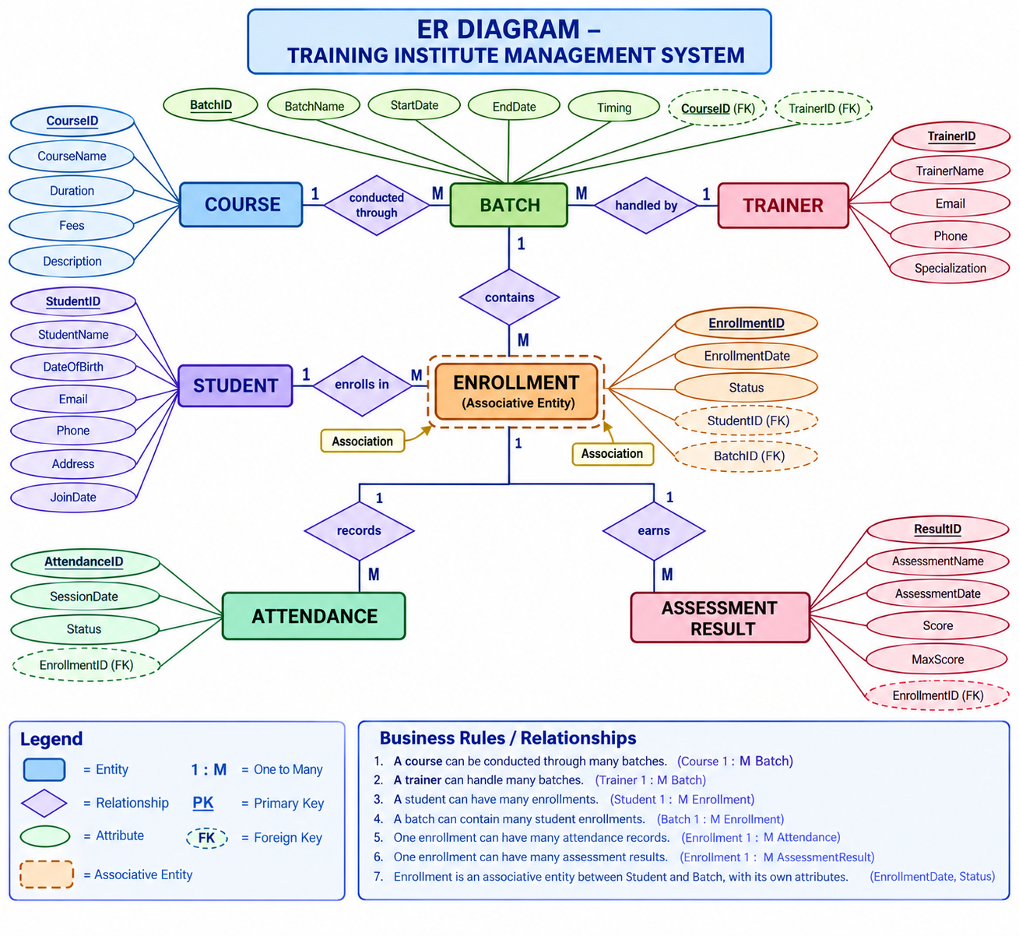
Figure 1: ER Diagram – Training Institute Management System

5. Entities and Attributes
Table | Represents | Primary key | Foreign keys
Student | A person who learns at the institute | StudentID | none
Trainer | A teacher employed by the institute | TrainerID | none
Course | A subject the institute teaches | CourseID | none
Batch | One scheduled run of a course with one trainer | BatchID | CourseID, TrainerID
Enrollment | The fact that a student joined a batch (bridge table) | EnrollmentID | StudentID, BatchID
Attendance | Presence or absence of an enrolled student in one session | AttendanceID | EnrollmentID
AssessmentResult | Score of an enrolled student in one test | ResultID | EnrollmentID

6. Table Relationships and Cardinality
Parent Table | Related Table | Relationship | Purpose
Course | Batch | 1 : M | One course can be conducted through multiple batches.
Trainer | Batch | 1 : M | One trainer can handle multiple batches.
Student | Enrollment | 1 : M | One student can have multiple enrollments.
Batch | Enrollment | 1 : M | One batch can contain multiple student enrollments.
Enrollment | Attendance | 1 : M | One enrollment can have multiple attendance records.
Enrollment | AssessmentResult | 1 : M | One enrolled student can receive multiple assessment results.
Student and Batch are many-to-many in real life, so Enrollment links them. Attendance and results belong to Enrollment because they describe one student in one batch.

7. Primary Keys and Foreign Keys
Table | Primary Key | Foreign Key(s)
Student | StudentID | —
Trainer | TrainerID | —
Course | CourseID | —
Batch | BatchID | CourseID → Course.CourseID; TrainerID → Trainer.TrainerID
Enrollment | EnrollmentID | StudentID → Student.StudentID; BatchID → Batch.BatchID
Attendance | AttendanceID | EnrollmentID → Enrollment.EnrollmentID
AssessmentResult | ResultID | EnrollmentID → Enrollment.EnrollmentID
No student, trainer, course or batch detail is stored twice: Batch keeps only CourseID and TrainerID, and names are read with joins (3NF).

8. Relational Schema / Table Structure
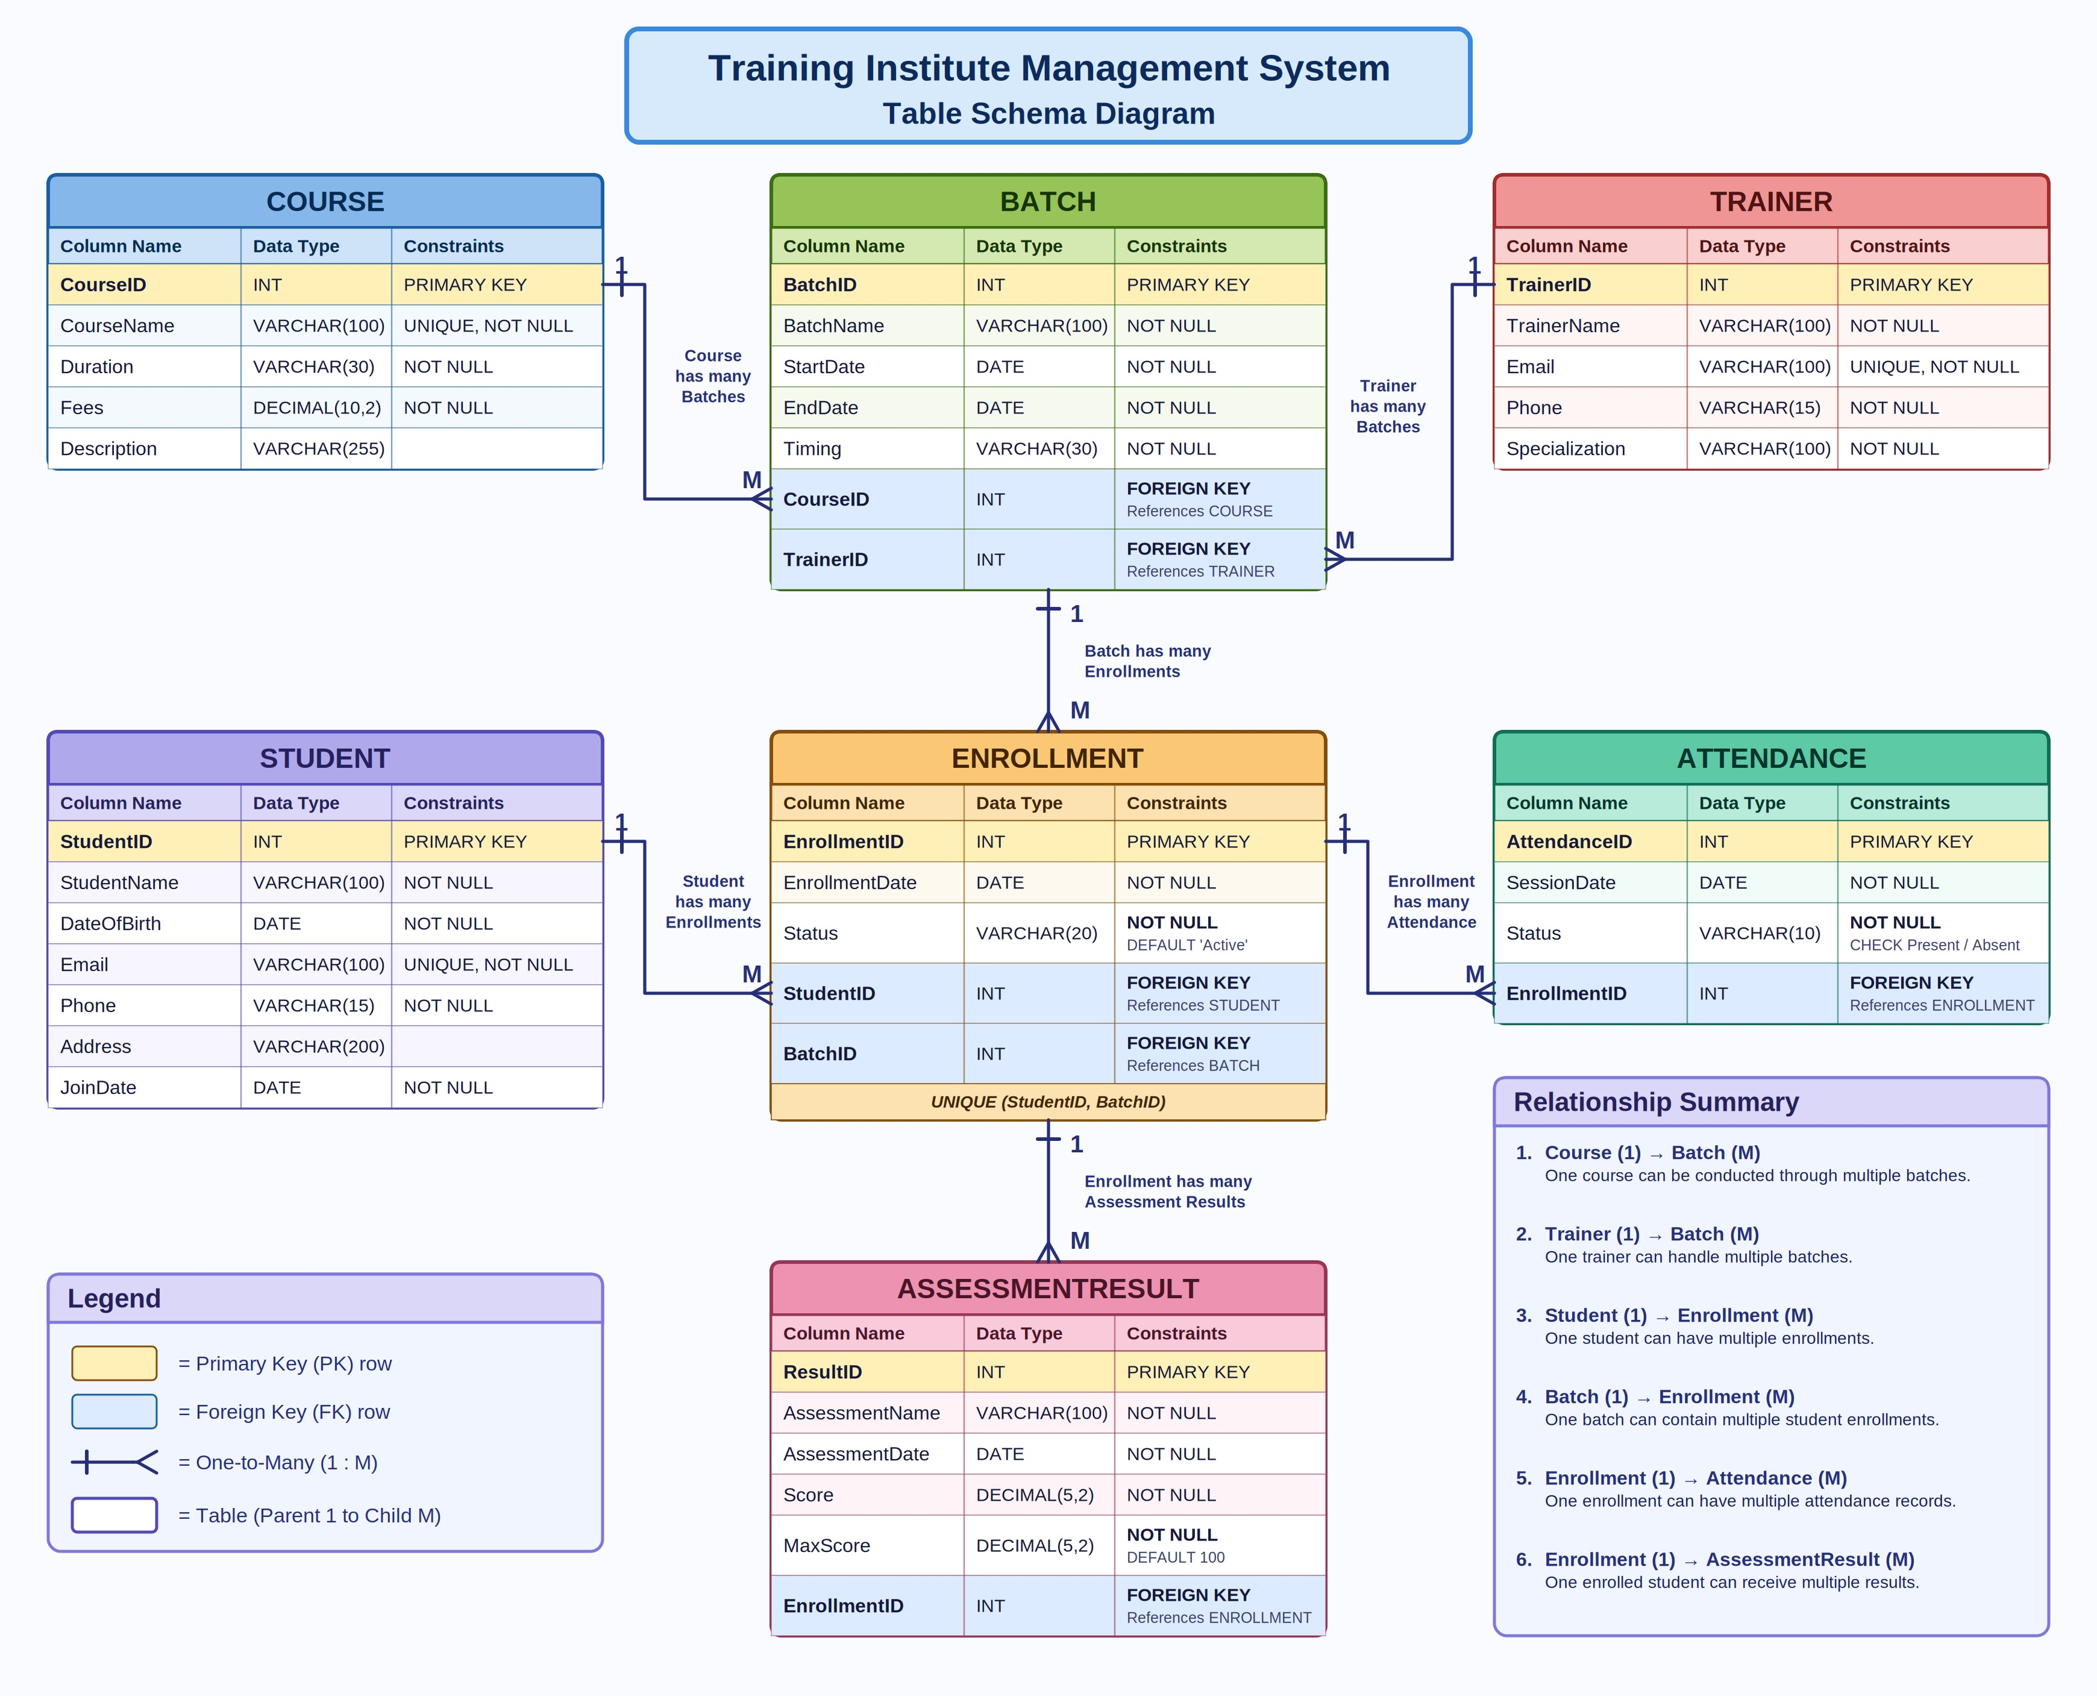
Figure 2: Table Schema Diagram (gold rows = primary keys, blue rows = foreign keys)

The structure of each table is given below with the data type, constraint and meaning of every column.
Student
Column | Data Type | Constraint | Meaning
StudentID | INT | PRIMARY KEY | Unique student number (auto-generated)
StudentName | VARCHAR(100) | NOT NULL | Full name of the student
DateOfBirth | DATE | NOT NULL | Date of birth
Email | VARCHAR(100) | NOT NULL, UNIQUE | E-mail address, must be unique
Phone | VARCHAR(15) | NOT NULL | Contact number
Address | VARCHAR(200) |  | Residential area (optional)
JoinDate | DATE | NOT NULL | Date the student joined the institute
Trainer
Column | Data Type | Constraint | Meaning
TrainerID | INT | PRIMARY KEY | Unique trainer number (auto-generated)
TrainerName | VARCHAR(100) | NOT NULL | Full name of the trainer
Email | VARCHAR(100) | NOT NULL, UNIQUE | E-mail address, must be unique
Phone | VARCHAR(15) | NOT NULL | Contact number
Specialization | VARCHAR(100) | NOT NULL | Subject area of expertise
Course
Column | Data Type | Constraint | Meaning
CourseID | INT | PRIMARY KEY | Unique course number (auto-generated)
CourseName | VARCHAR(100) | NOT NULL, UNIQUE | Name of the course, must be unique
Duration | VARCHAR(30) | NOT NULL | Length of the course, e.g. 6 months
Fees | DECIMAL(10,2) | NOT NULL | Course fee in rupees
Description | VARCHAR(255) |  | Short description (optional)
Batch
Column | Data Type | Constraint | Meaning
BatchID | INT | PRIMARY KEY | Unique batch number (auto-generated)
BatchName | VARCHAR(100) | NOT NULL | Batch label, e.g. JFS-Morning
StartDate | DATE | NOT NULL | First day of the batch
EndDate | DATE | NOT NULL | Last day of the batch
Timing | VARCHAR(30) | NOT NULL | Daily time slot
CourseID | INT | NOT NULL, FK | Course taught in this batch (parent: Course)
TrainerID | INT | NOT NULL, FK | Trainer handling this batch (parent: Trainer)
Enrollment
Column | Data Type | Constraint | Meaning
EnrollmentID | INT | PRIMARY KEY | Unique enrollment number (auto-generated)
EnrollmentDate | DATE | NOT NULL | Date the student joined the batch
Status | VARCHAR(20) | NOT NULL, DEFAULT 'Active' | Enrollment status, Active by default
StudentID | INT | NOT NULL, FK | Student who joined (parent: Student)
BatchID | INT | NOT NULL, FK | Batch joined (parent: Batch)
Extra constraint: UNIQUE (StudentID, BatchID) so a student cannot join the same batch twice.

Attendance
Column | Data Type | Constraint | Meaning
AttendanceID | INT | PRIMARY KEY | Unique attendance record number
SessionDate | DATE | NOT NULL | Date of the session
Status | VARCHAR(10) | NOT NULL, CHECK (Present / Absent) | Present or Absent
EnrollmentID | INT | NOT NULL, FK | Enrollment this record belongs to (parent: Enrollment)
AssessmentResult
Column | Data Type | Constraint | Meaning
ResultID | INT | PRIMARY KEY | Unique result number
AssessmentName | VARCHAR(100) | NOT NULL | Name of the test, e.g. Unit Test 1
AssessmentDate | DATE | NOT NULL | Date of the test
Score | DECIMAL(5,2) | NOT NULL | Marks obtained
MaxScore | DECIMAL(5,2) | NOT NULL, DEFAULT 100 | Maximum marks (default 100)
EnrollmentID | INT | NOT NULL, FK | Enrollment that earned the score (parent: Enrollment)

9. MySQL Database Creation and Table Creation
The script creates the database and the seven tables with PRIMARY KEY, FOREIGN KEY, NOT NULL, UNIQUE and CHECK constraints. Parent tables are created first.
DROP DATABASE IF EXISTS TrainingInstitute;
CREATE DATABASE TrainingInstitute;
USE TrainingInstitute;

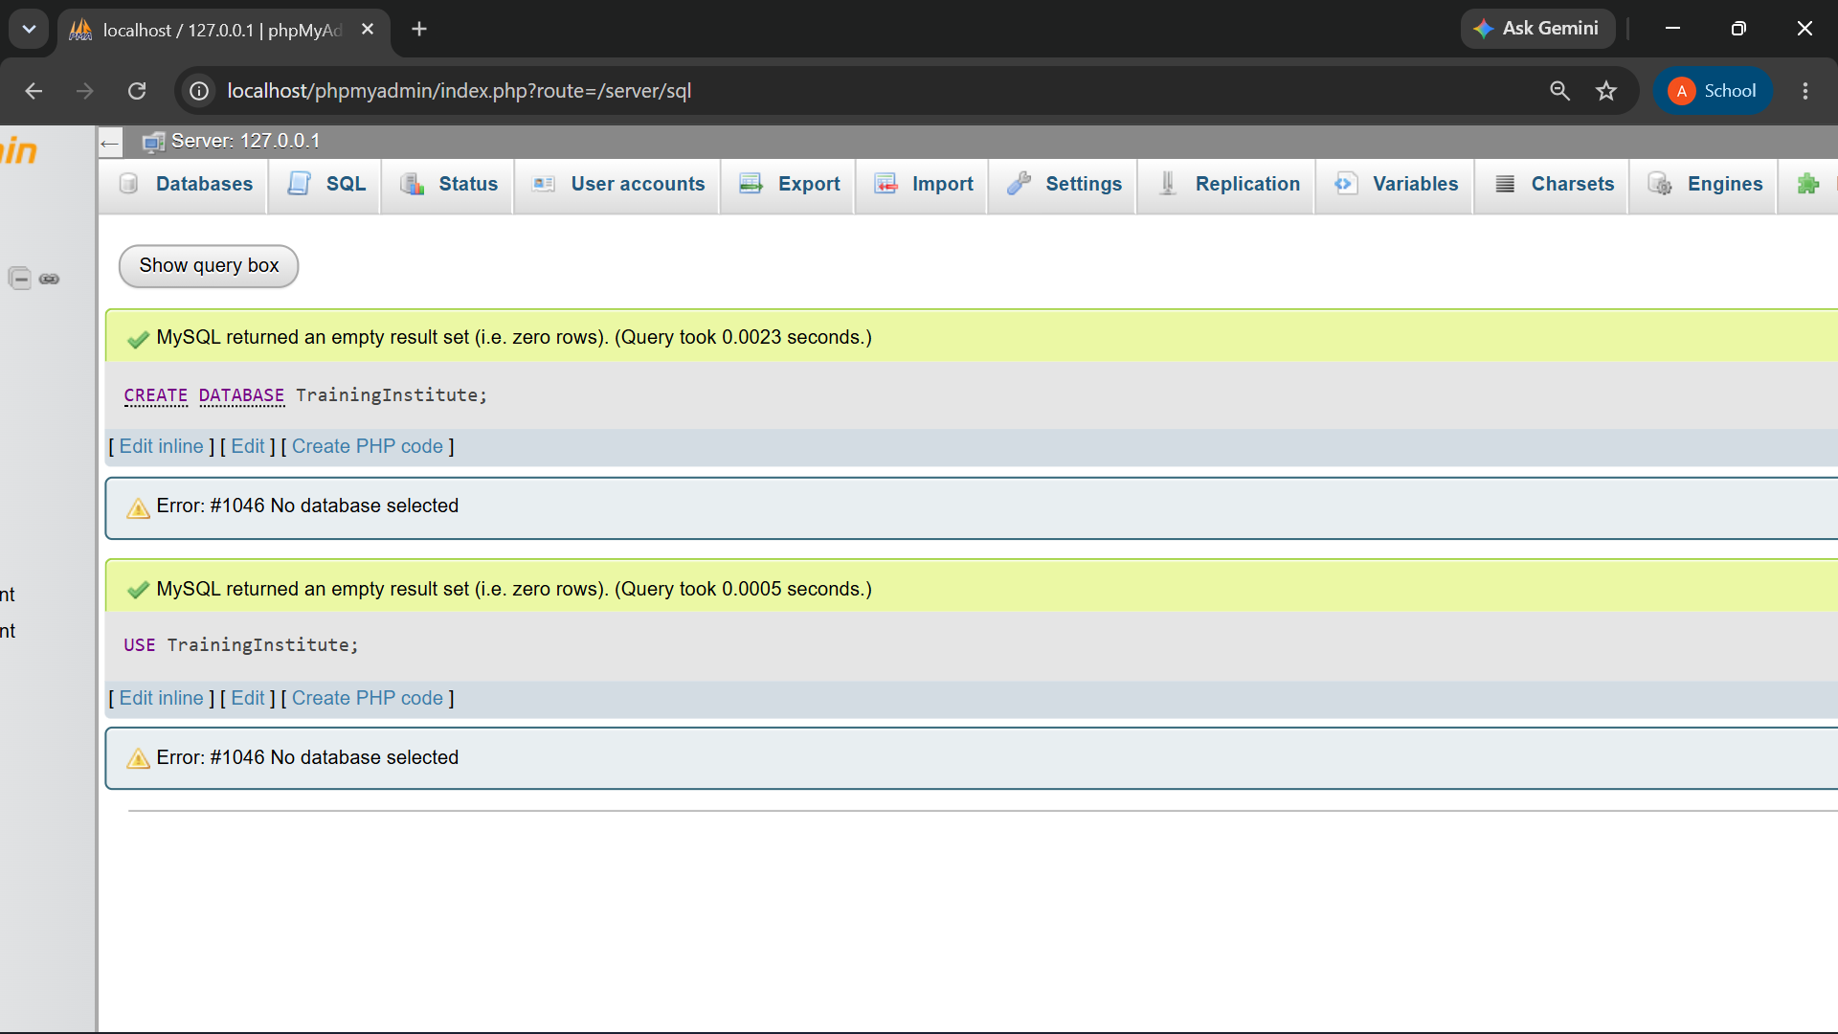

Student

CREATE TABLE Student (
StudentID INT AUTO_INCREMENT PRIMARY KEY,
StudentName VARCHAR(100) NOT NULL,
DateOfBirth DATE NOT NULL,
Email VARCHAR(100) NOT NULL UNIQUE,
Phone VARCHAR(15) NOT NULL,
Address VARCHAR(200),
JoinDate DATE NOT NULL
);

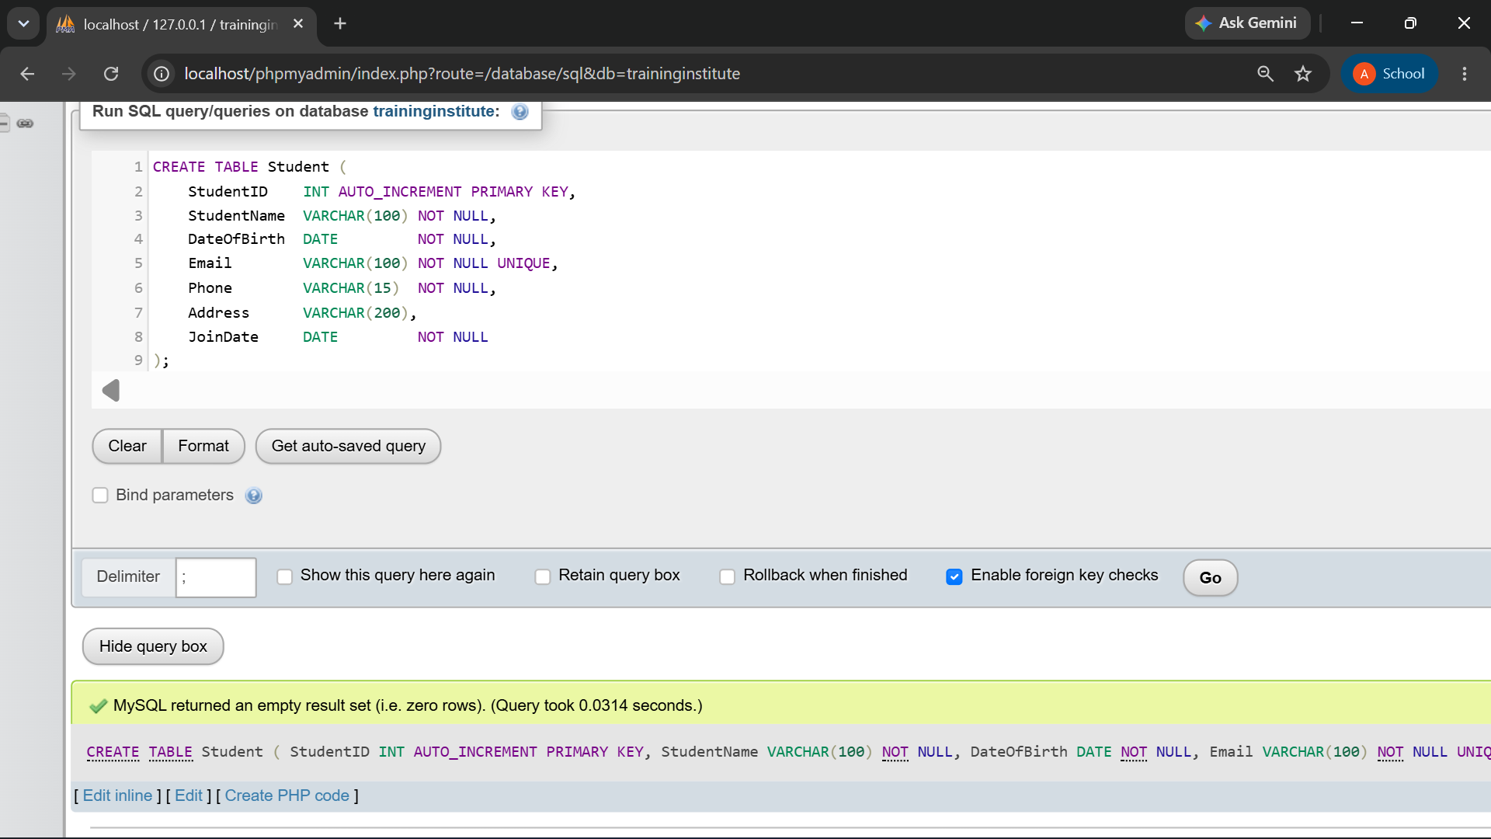

Trainer

CREATE TABLE Trainer (
TrainerID INT AUTO_INCREMENT PRIMARY KEY,
TrainerName VARCHAR(100) NOT NULL,
Email VARCHAR(100) NOT NULL UNIQUE,
Phone VARCHAR(15) NOT NULL,
Specialization VARCHAR(100) NOT NULL
);
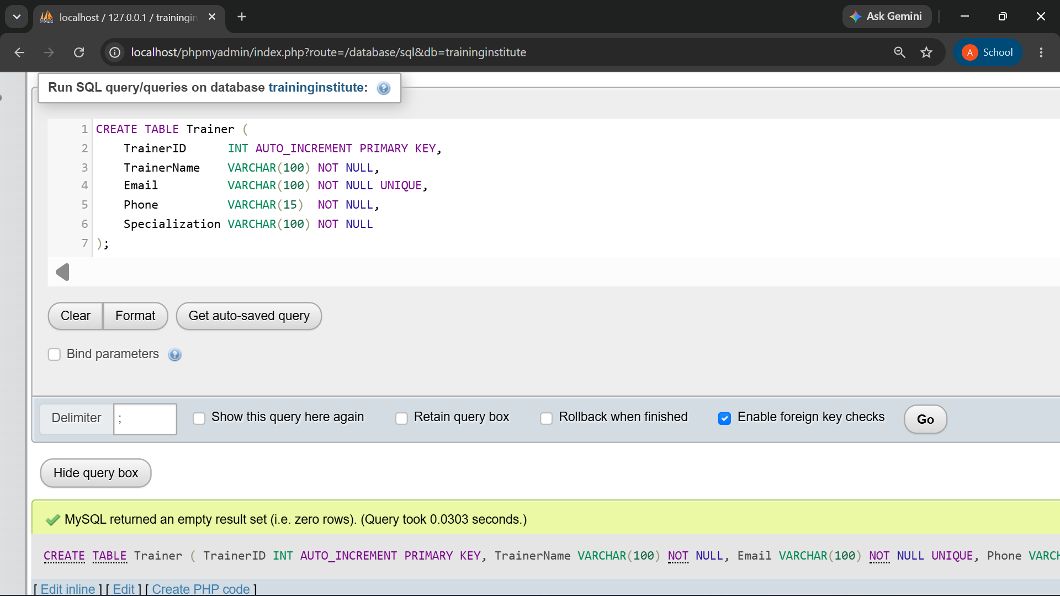

Course

CREATE TABLE Course (
CourseID INT AUTO_INCREMENT PRIMARY KEY,
CourseName VARCHAR(100) NOT NULL UNIQUE,
Duration VARCHAR(30) NOT NULL,
Fees DECIMAL(10,2) NOT NULL,
Description VARCHAR(255)
);

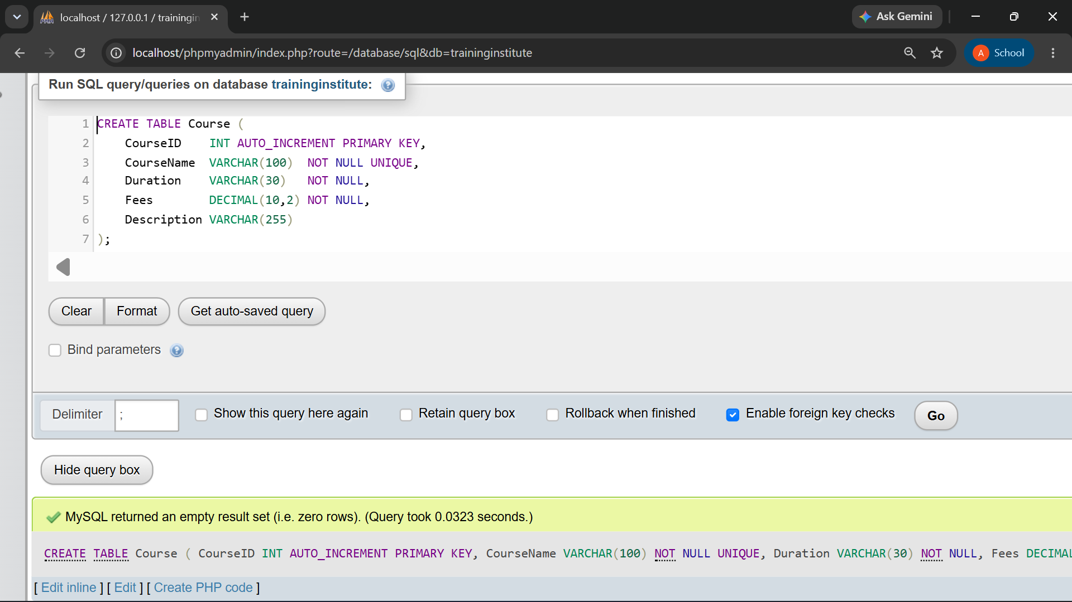

Batch

CREATE TABLE Batch (
BatchID INT AUTO_INCREMENT PRIMARY KEY,
BatchName VARCHAR(100) NOT NULL,
StartDate DATE NOT NULL,
EndDate DATE NOT NULL,
Timing VARCHAR(30) NOT NULL,
CourseID INT NOT NULL,
TrainerID INT NOT NULL,
FOREIGN KEY (CourseID) REFERENCES Course(CourseID),
FOREIGN KEY (TrainerID) REFERENCES Trainer(TrainerID)
);

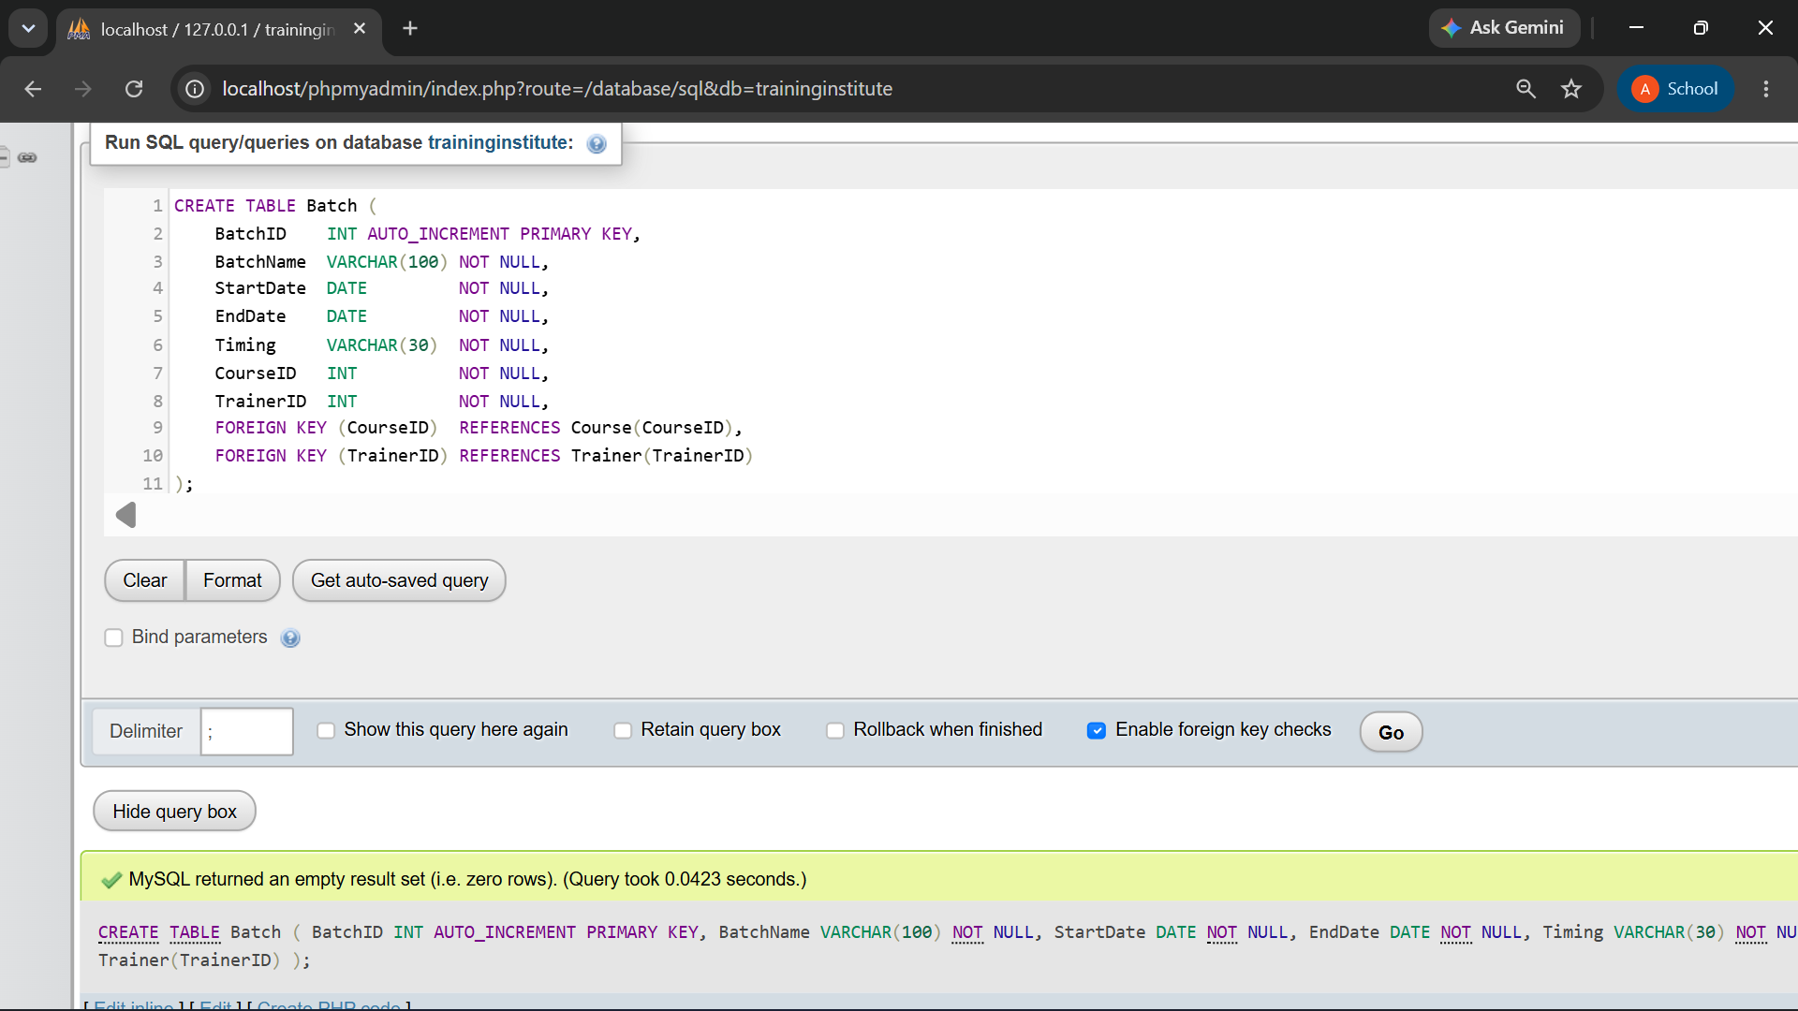

Enrollment

CREATE TABLE Enrollment (
EnrollmentID INT AUTO_INCREMENT PRIMARY KEY,
EnrollmentDate DATE NOT NULL,
Status VARCHAR(20) NOT NULL DEFAULT 'Active',
StudentID INT NOT NULL,
BatchID INT NOT NULL,
FOREIGN KEY (StudentID) REFERENCES Student(StudentID),
FOREIGN KEY (BatchID) REFERENCES Batch(BatchID),
UNIQUE (StudentID, BatchID) -- same student cannot join a batch twice
);

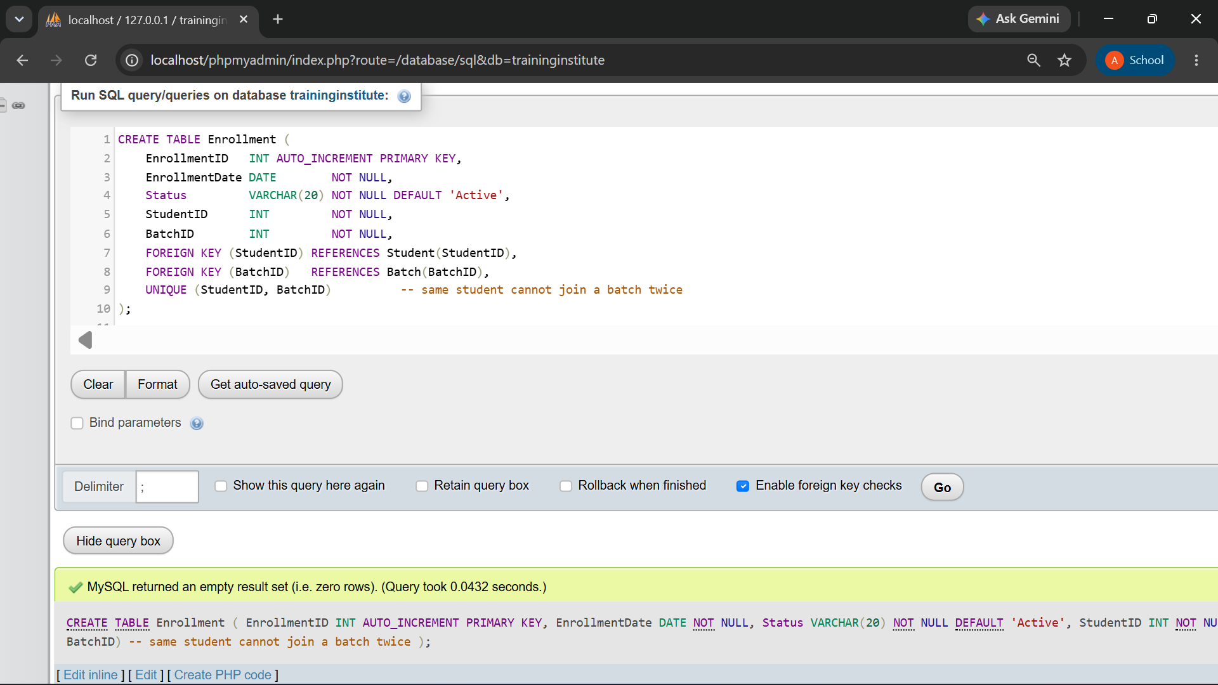

Attendance

CREATE TABLE Attendance (
AttendanceID INT AUTO_INCREMENT PRIMARY KEY,
SessionDate DATE NOT NULL,
Status VARCHAR(10) NOT NULL CHECK (Status IN ('Present','Absent')),
EnrollmentID INT NOT NULL,
FOREIGN KEY (EnrollmentID) REFERENCES Enrollment(EnrollmentID)
);

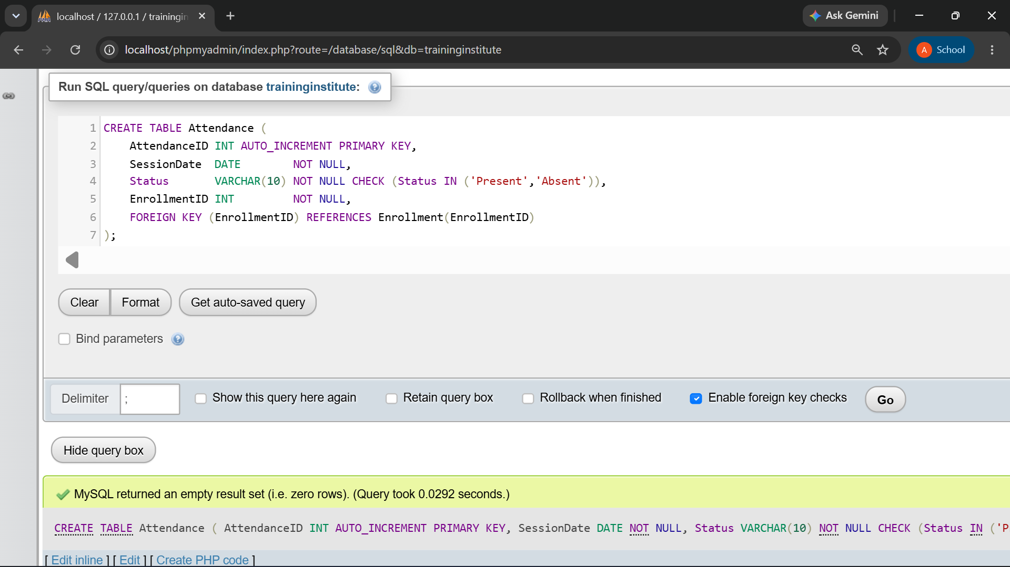

AssessmentResult

CREATE TABLE AssessmentResult (
ResultID INT AUTO_INCREMENT PRIMARY KEY,
AssessmentName VARCHAR(100) NOT NULL,
AssessmentDate DATE NOT NULL,
Score DECIMAL(5,2) NOT NULL,
MaxScore DECIMAL(5,2) NOT NULL DEFAULT 100,
EnrollmentID INT NOT NULL,
FOREIGN KEY (EnrollmentID) REFERENCES Enrollment(EnrollmentID)
);
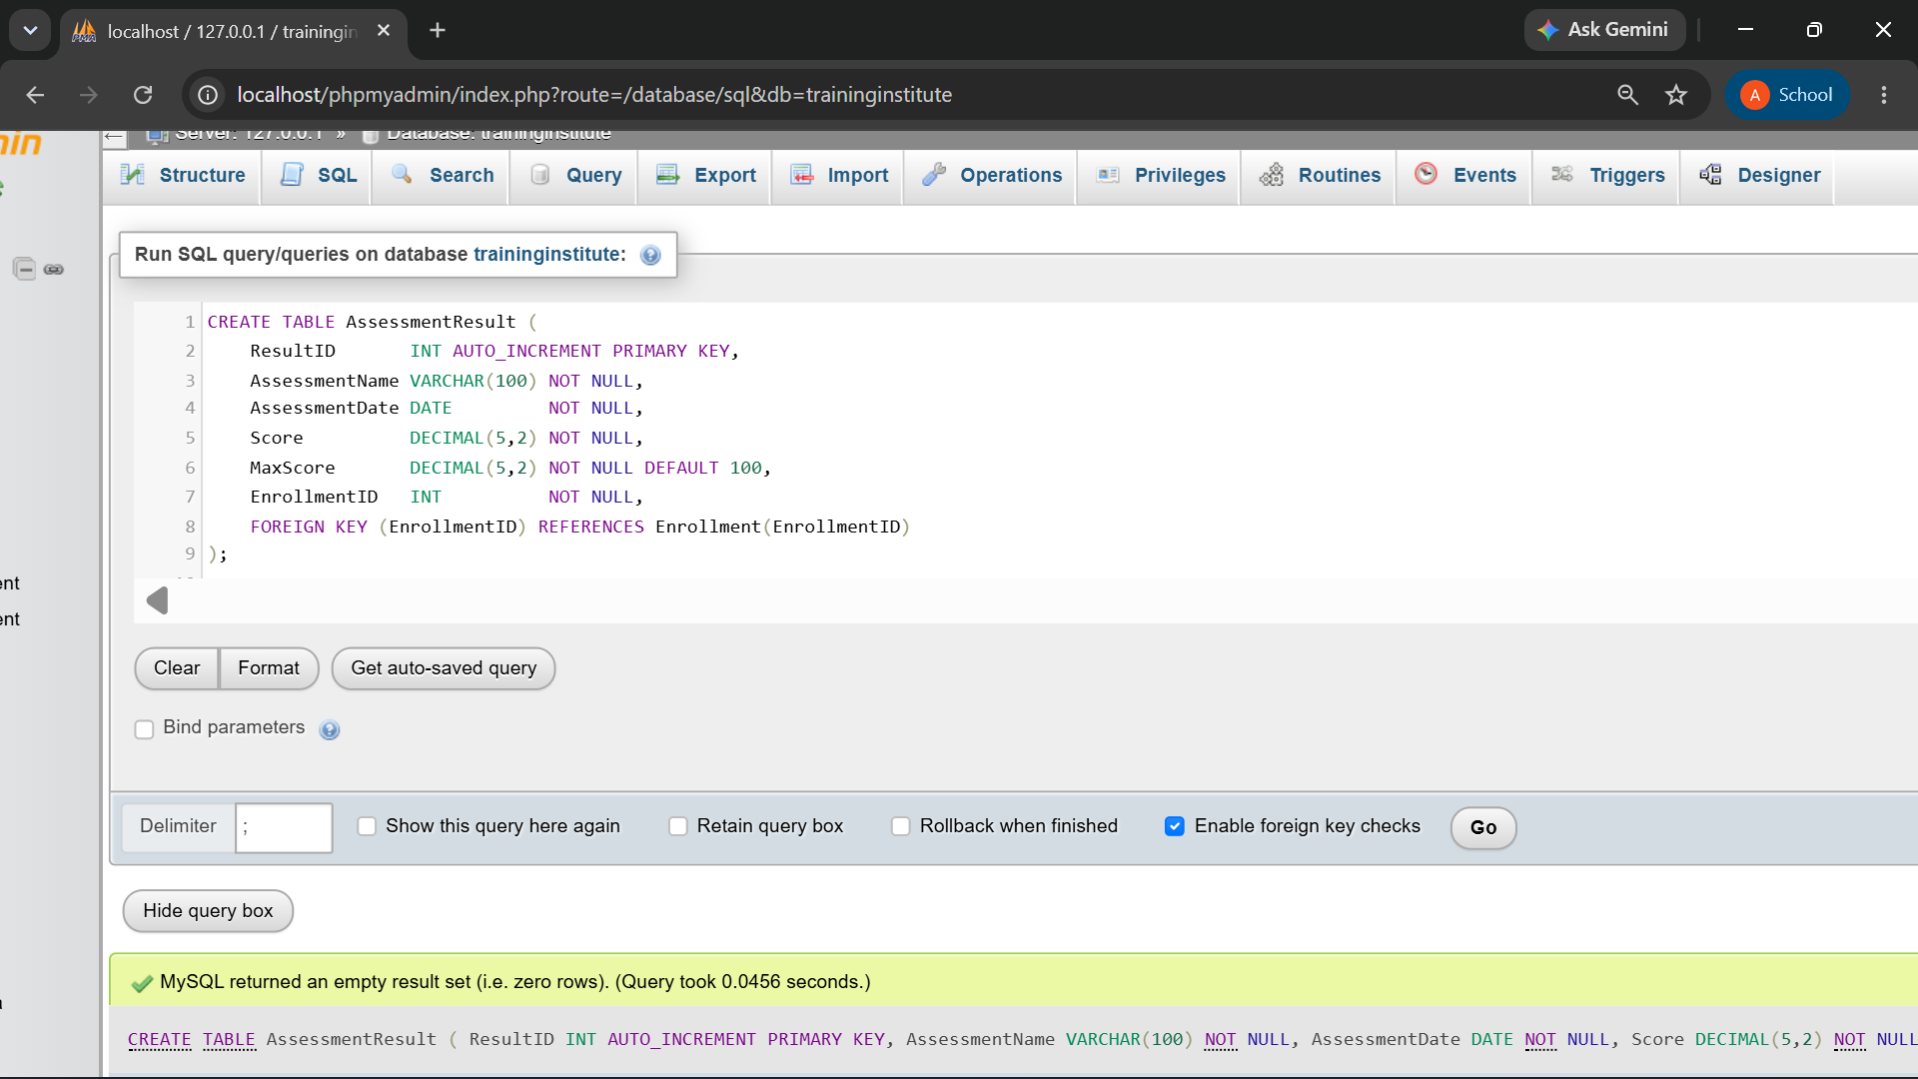

10. Sample Data
Realistic sample records were inserted into every table (full INSERT statements are in the separate script file).

-- 1. STUDENT DATA

INSERT INTO Student
(StudentID, StudentName, DateOfBirth, Email, Phone, Address, JoinDate) VALUES
(1, 'Aarohi Mhatre', '2005-04-12', 'aarohi.mhatre@gmail.com', '9876543210', 'Kothrud, Pune', '2026-07-25'),
(2, 'Yashvardhan Kale', '2004-11-08', 'yashvardhan.kale@gmail.com', '9823456712', 'Vashi, Navi Mumbai', '2026-07-25'),
(3, 'Kiara Nene', '2005-02-19', 'kiara.nene@gmail.com', '9765432189', 'Baner, Pune', '2026-07-26'),
(4, 'Dhruv Karkhanis', '2004-08-27', 'dhruv.karkhanis@gmail.com', '9890123456', 'Thane West, Thane', '2026-07-27'),
(5, 'Saanvi Limaye', '2005-06-15', 'saanvi.limaye@gmail.com', '9812345678', 'Wakad, Pune', '2026-07-27'),
(6, 'Rudra Bapat', '2004-12-03', 'rudra.bapat@gmail.com', '9753124680', 'College Road, Nashik', '2026-07-28'),
(7, 'Avni Gokhale', '2005-01-22', 'avni.gokhale@gmail.com', '9867452310', 'Rajarampuri, Kolhapur', '2026-07-28'),
(8, 'Parth Oak', '2004-09-17', 'parth.oak@gmail.com', '9934567812', 'Aundh, Pune', '2026-07-29'),
(9, 'Ira Mahajan', '2005-03-11', 'ira.mahajan@gmail.com', '9786543120', 'Dharampeth, Nagpur', '2026-07-29'),
(10, 'Reyansh Tamhane', '2004-07-29', 'reyansh.tamhane@gmail.com', '9845123670', 'Hadapsar, Pune', '2026-07-30'),
(11, 'Myra Dandekar', '2005-05-06', 'myra.dandekar@gmail.com', '9798234510', 'Rajwada, Satara', '2026-07-30'),
(12, 'Atharv Vaze', '2004-10-14', 'atharv.vaze@gmail.com', '9912345678', 'Viman Nagar, Pune', '2026-07-31'),
(13, 'Anushree Modak', '2005-02-28', 'anushree.modak@gmail.com', '9871234560', 'Andheri, Mumbai', '2026-07-31'),
(14, 'Neil Kshirsagar', '2004-06-21', 'neil.kshirsagar@gmail.com', '9834567120', 'Kharadi, Pune', '2026-08-01'),
(15, 'Samaira Kamat', '2005-09-09', 'samaira.kamat@gmail.com', '9768123450', 'Savedi, Ahmednagar', '2026-08-01');

SELECT * FROM Student;
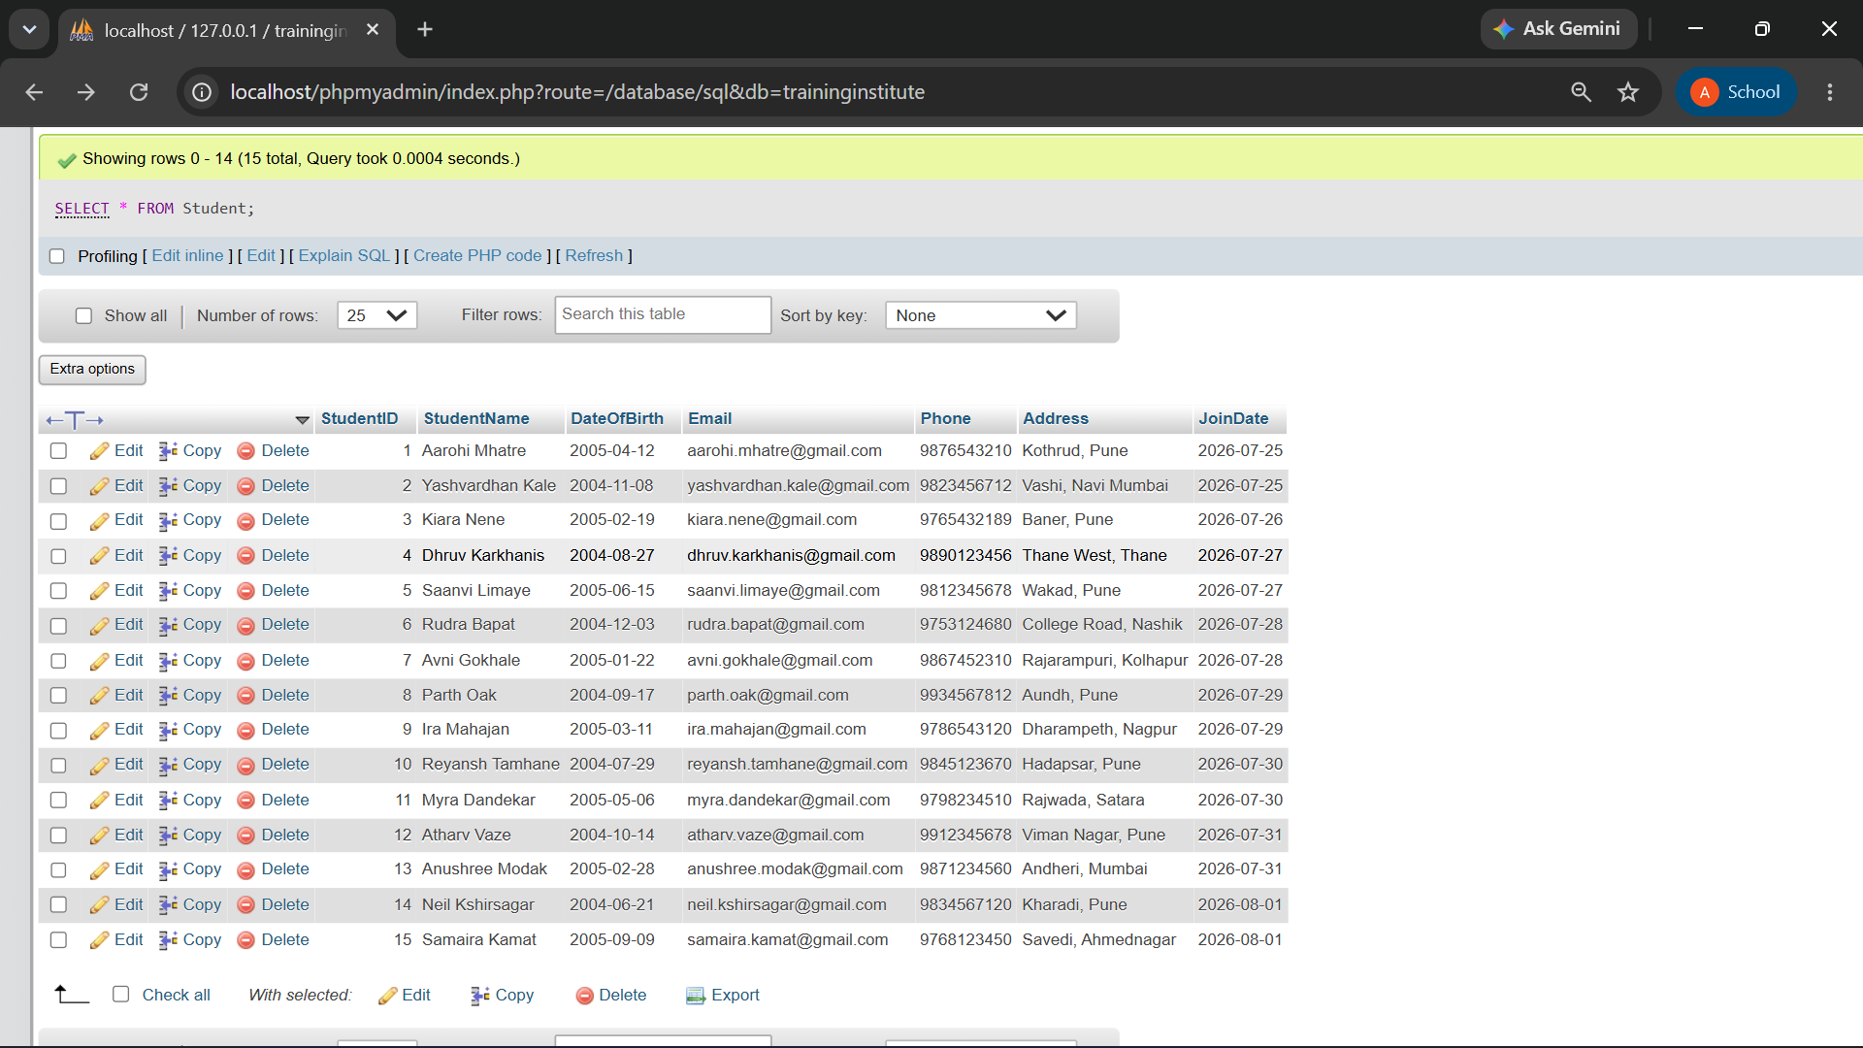

-- 2. TRAINER DATA

INSERT INTO Trainer
(TrainerID, TrainerName, Email, Phone, Specialization) VALUES
(101, 'Vikram Chitale', 'vikram.chitale@gmail.com', '9876543210', 'Java Enterprise Development'),
(102, 'Rhea Apte', 'rhea.apte@gmail.com', '9823456712', 'Frontend Engineering'),
(103, 'Nikhil Pansare', 'nikhil.pansare@gmail.com', '9765432189', 'Machine Learning and Python'),
(104, 'Sonal Bendre', 'sonal.bendre@gmail.com', '9890123456', 'Brand Strategy and Marketing');

SELECT * FROM Trainer;

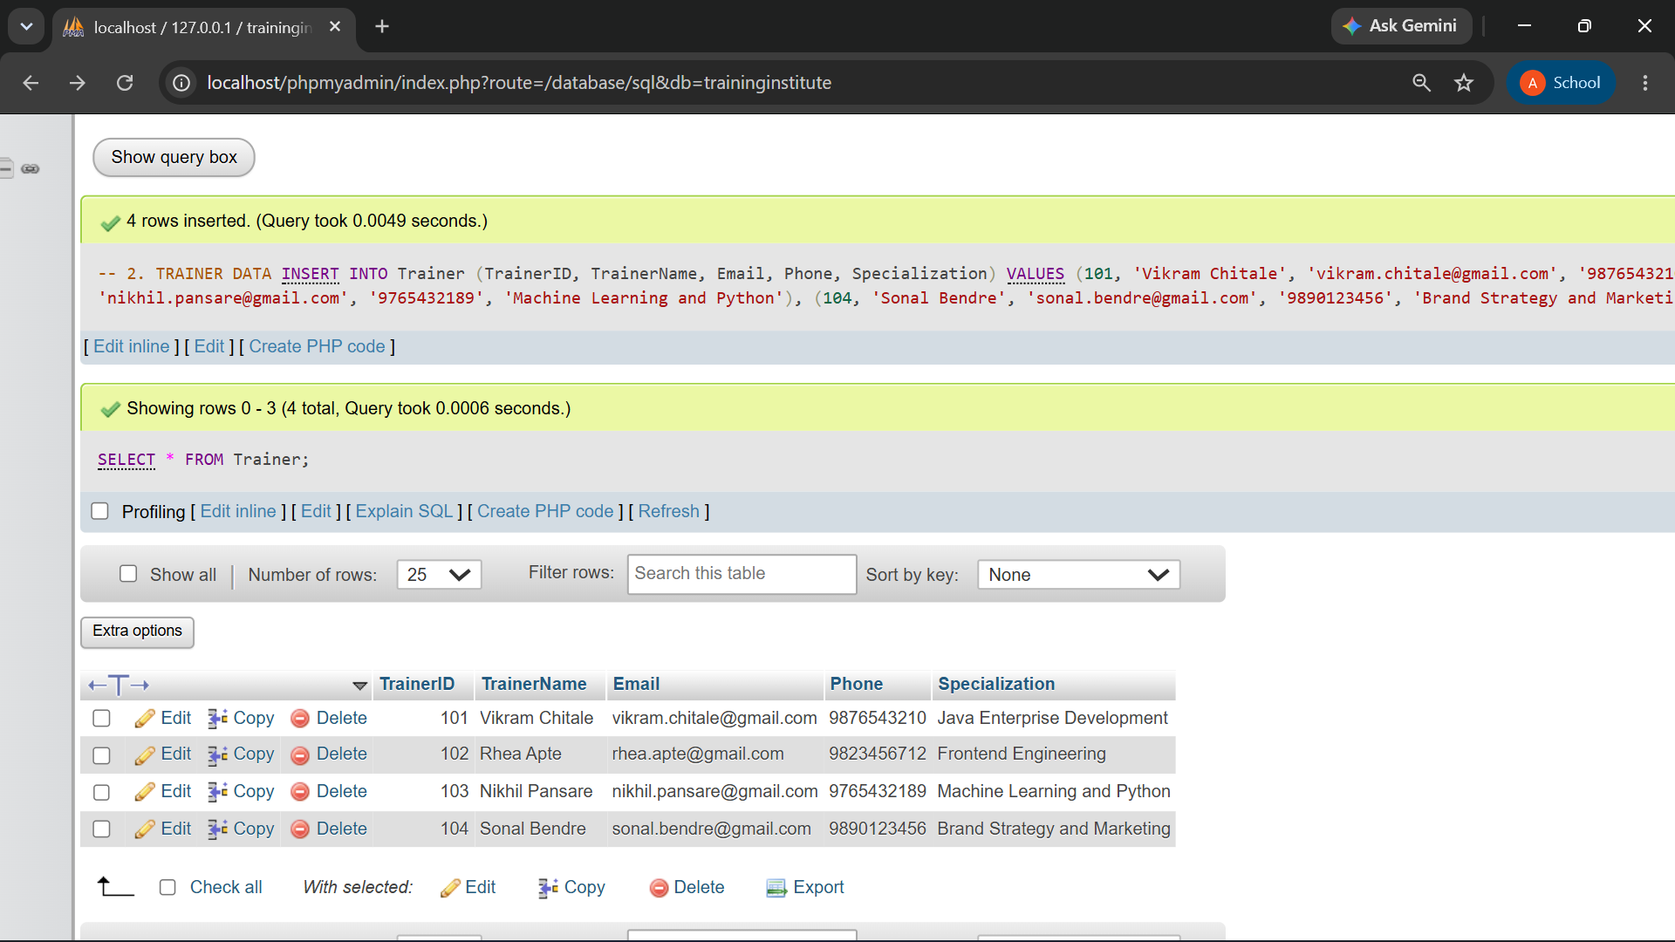

-- 3. COURSE DATA

INSERT INTO Course
(CourseID, CourseName, Duration, Fees, Description) VALUES
(201, 'Enterprise Java Programming', '5 Months', 42000.00, 'Java and enterprise applications'),
(202, 'Applied Python Analytics', '4 Months', 36000.00, 'Python and data analysis'),
(203, 'Frontend UI Development', '3 Months', 27000.00, 'HTML, CSS and JavaScript'),
(204, 'Digital Branding Fundamentals', '2 Months', 19500.00, 'Digital marketing and branding');

SELECT * FROM Course;

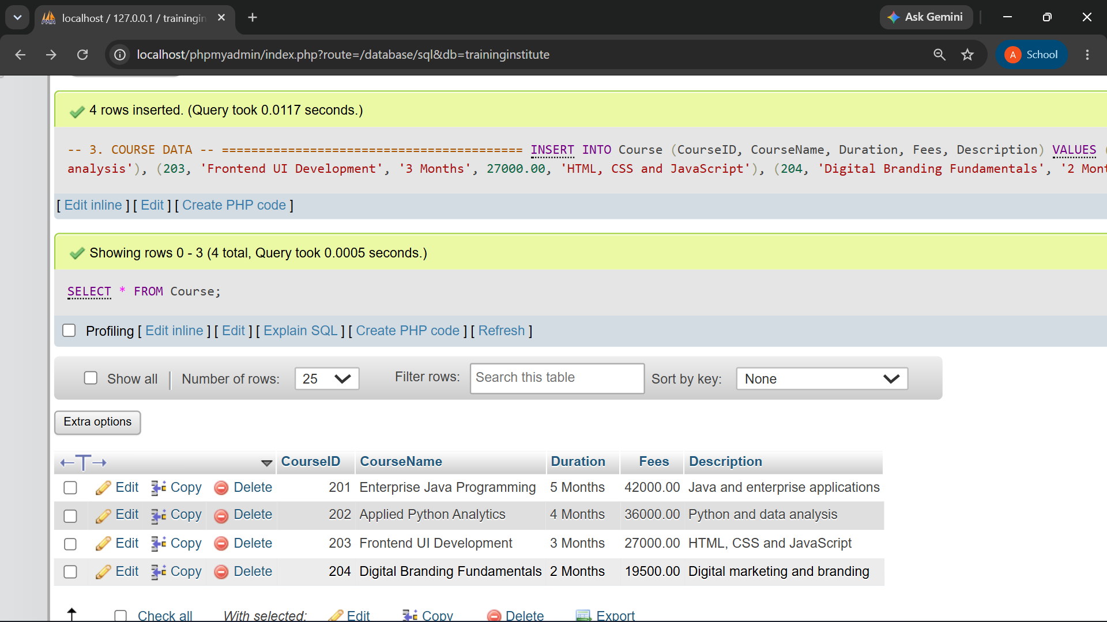

-- 4. BATCH DATA

INSERT INTO Batch
(BatchID, BatchName, StartDate, EndDate, Timing, CourseID, TrainerID) VALUES
(301, 'EJP-Afternoon', '2026-08-03', '2027-01-03', '2 PM - 4 PM', 201, 101),
(302, 'EJP-Saturday', '2026-08-08', '2027-01-08', '10 AM - 1 PM', 201, 101),
(303, 'APA-Morning', '2026-08-04', '2026-12-04', '9 AM - 11 AM', 202, 103),
(304, 'APA-Weekend', '2026-08-09', '2026-12-09', '11 AM - 2 PM', 202, 103),
(305, 'FUI-Evening', '2026-08-05', '2026-11-05', '5 PM - 7 PM', 203, 102),
(306, 'DBF-Afternoon', '2026-08-06', '2026-10-06', '2 PM - 4 PM', 204, 104);

SELECT * FROM Batch;
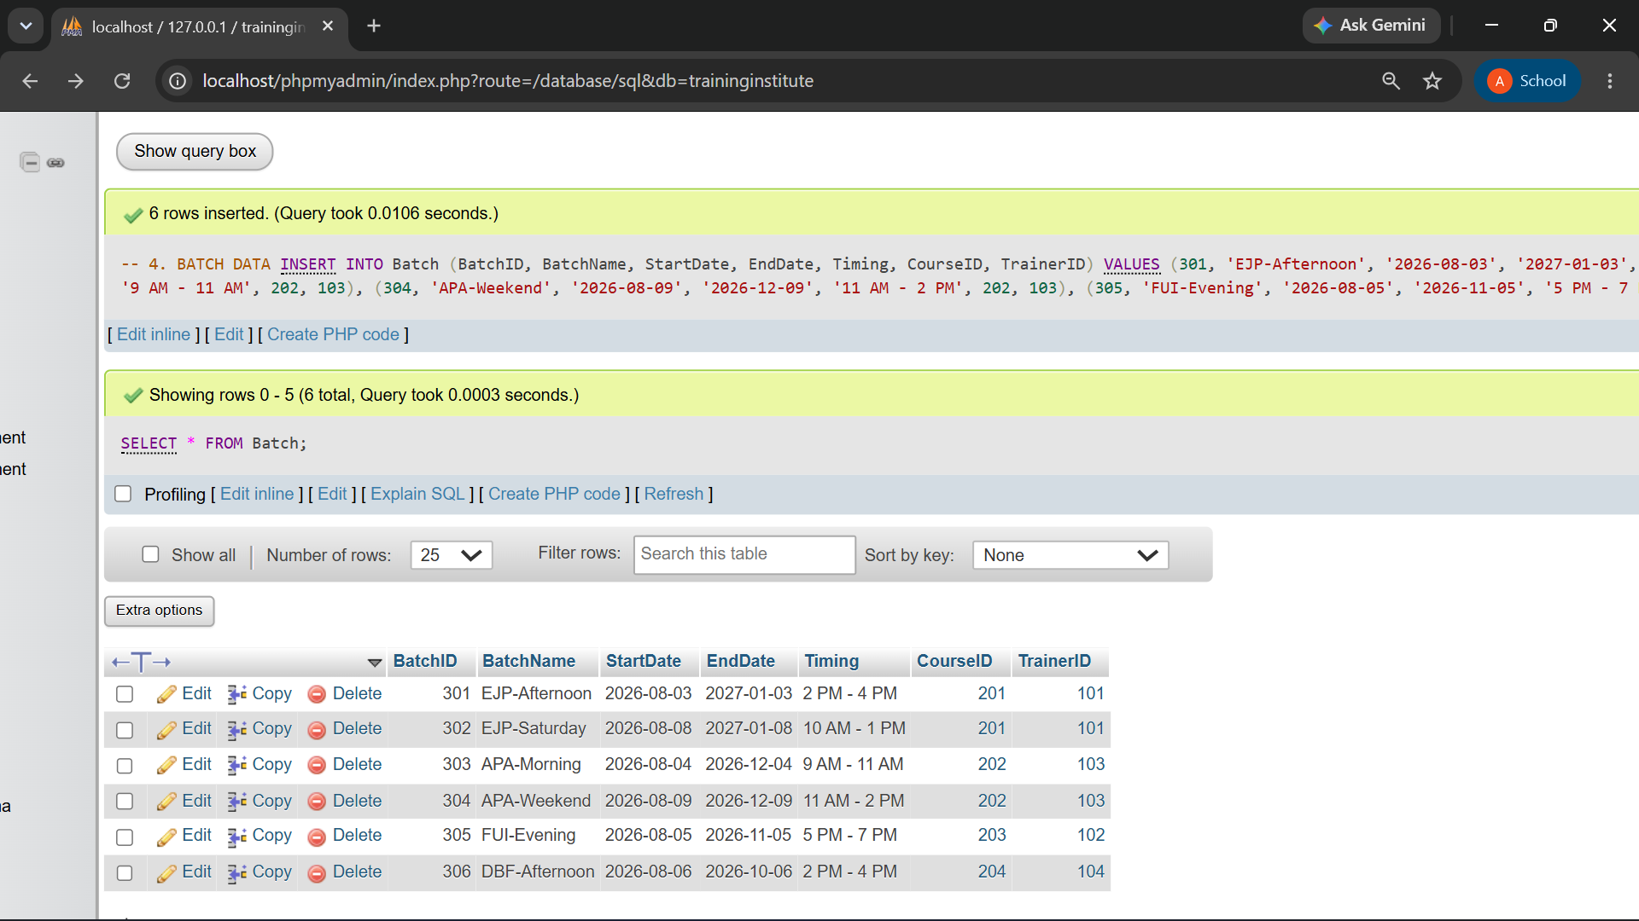

-- =========================================
-- 5. ENROLLMENT DATA
-- =========================================

INSERT INTO Enrollment
(EnrollmentID, EnrollmentDate, Status, StudentID, BatchID) VALUES
(401, '2026-07-25', 'Active', 1, 301),
(402, '2026-07-25', 'Active', 2, 301),
(403, '2026-07-26', 'Active', 3, 301),
(404, '2026-07-27', 'Active', 4, 302),
(405, '2026-07-27', 'Active', 5, 302),
(406, '2026-07-28', 'Active', 6, 303),
(407, '2026-07-28', 'Active', 7, 303),
(408, '2026-07-29', 'Active', 8, 303),
(409, '2026-07-29', 'Active', 9, 304),
(410, '2026-07-30', 'Active', 10, 304),
(411, '2026-07-30', 'Active', 11, 305),
(412, '2026-07-31', 'Active', 12, 305),
(413, '2026-07-31', 'Active', 13, 305),
(414, '2026-08-01', 'Active', 14, 306),
(415, '2026-08-01', 'Active', 15, 306),
(416, '2026-08-01', 'Active', 1, 305),
(417, '2026-08-02', 'Active', 2, 303),
(418, '2026-08-02', 'Active', 4, 306),
(419, '2026-08-02', 'Active', 7, 304),
(420, '2026-08-03', 'Active', 12, 306);

SELECT * FROM Enrollment;

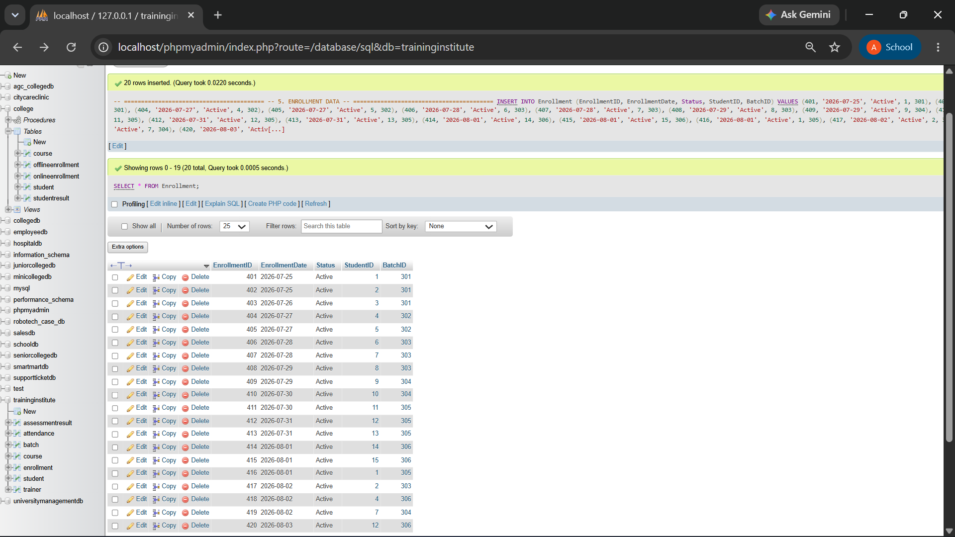

-- 6. ATTENDANCE DATA
-- =========================================

INSERT INTO Attendance
(AttendanceID, SessionDate, Status, EnrollmentID) VALUES
(501, '2026-08-04', 'Present', 401),
(502, '2026-08-04', 'Absent', 402),
(503, '2026-08-04', 'Present', 403),
(504, '2026-08-04', 'Present', 404),
(505, '2026-08-04', 'Absent', 405),
(506, '2026-08-04', 'Present', 406),
(507, '2026-08-04', 'Present', 407),
(508, '2026-08-04', 'Absent', 408),
(509, '2026-08-04', 'Present', 409),
(510, '2026-08-04', 'Present', 410),
(511, '2026-08-07', 'Present', 411),
(512, '2026-08-07', 'Absent', 412),
(513, '2026-08-07', 'Present', 413),
(514, '2026-08-07', 'Present', 414),
(515, '2026-08-07', 'Absent', 415),
(516, '2026-08-07', 'Present', 416),
(517, '2026-08-07', 'Present', 417),
(518, '2026-08-07', 'Absent', 418),
(519, '2026-08-07', 'Present', 419),
(520, '2026-08-07', 'Present', 420);

SELECT * FROM Attendance;
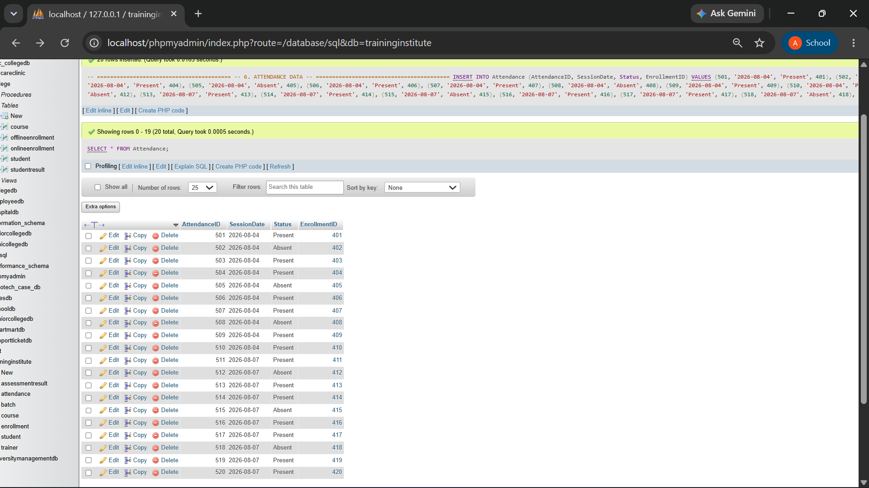

-- 7. ASSESSMENT RESULT DATA
-- =========================================

INSERT INTO AssessmentResult
(ResultID, AssessmentName, AssessmentDate, Score, MaxScore, EnrollmentID) VALUES
(601, 'Java OOP Test', '2026-08-18', 78.00, 100.00, 401),
(602, 'Java OOP Test', '2026-08-18', 84.00, 100.00, 402),
(603, 'Java Collections Test', '2026-08-18', 91.00, 100.00, 403),
(604, 'Java Collections Test', '2026-08-18', 73.00, 100.00, 404),
(605, 'Java Exception Handling Test', '2026-08-19', 88.00, 100.00, 405),
(606, 'Python Functions Test', '2026-08-20', 81.00, 100.00, 406),
(607, 'Python Functions Test', '2026-08-20', 76.00, 100.00, 407),
(608, 'Pandas DataFrame Test', '2026-08-20', 89.00, 100.00, 408),
(609, 'Pandas DataFrame Test', '2026-08-21', 93.00, 100.00, 409),
(610, 'Python Data Analysis Test', '2026-08-21', 79.00, 100.00, 410),
(611, 'HTML and CSS Test', '2026-08-22', 87.00, 100.00, 411),
(612, 'HTML and CSS Test', '2026-08-22', 82.00, 100.00, 412),
(613, 'JavaScript Basics Test', '2026-08-22', 95.00, 100.00, 413),

(614, 'Digital Marketing Test', '2026-08-23', 71.00, 100.00, 414),
(615, 'Digital Marketing Test', '2026-08-23', 86.00, 100.00, 415),
(616, 'JavaScript Basics Test', '2026-08-24', 80.00, 100.00, 416),
(617, 'Python Data Analysis Test', '2026-08-24', 92.00, 100.00, 417),
(618, 'Digital Marketing Test', '2026-08-25', 75.00, 100.00, 418),
(619, 'Pandas DataFrame Test', '2026-08-25', 83.00, 100.00, 419),
(620, 'Brand Strategy Test', '2026-08-26', 90.00, 100.00, 420);

SELECT * FROM AssessmentResult;
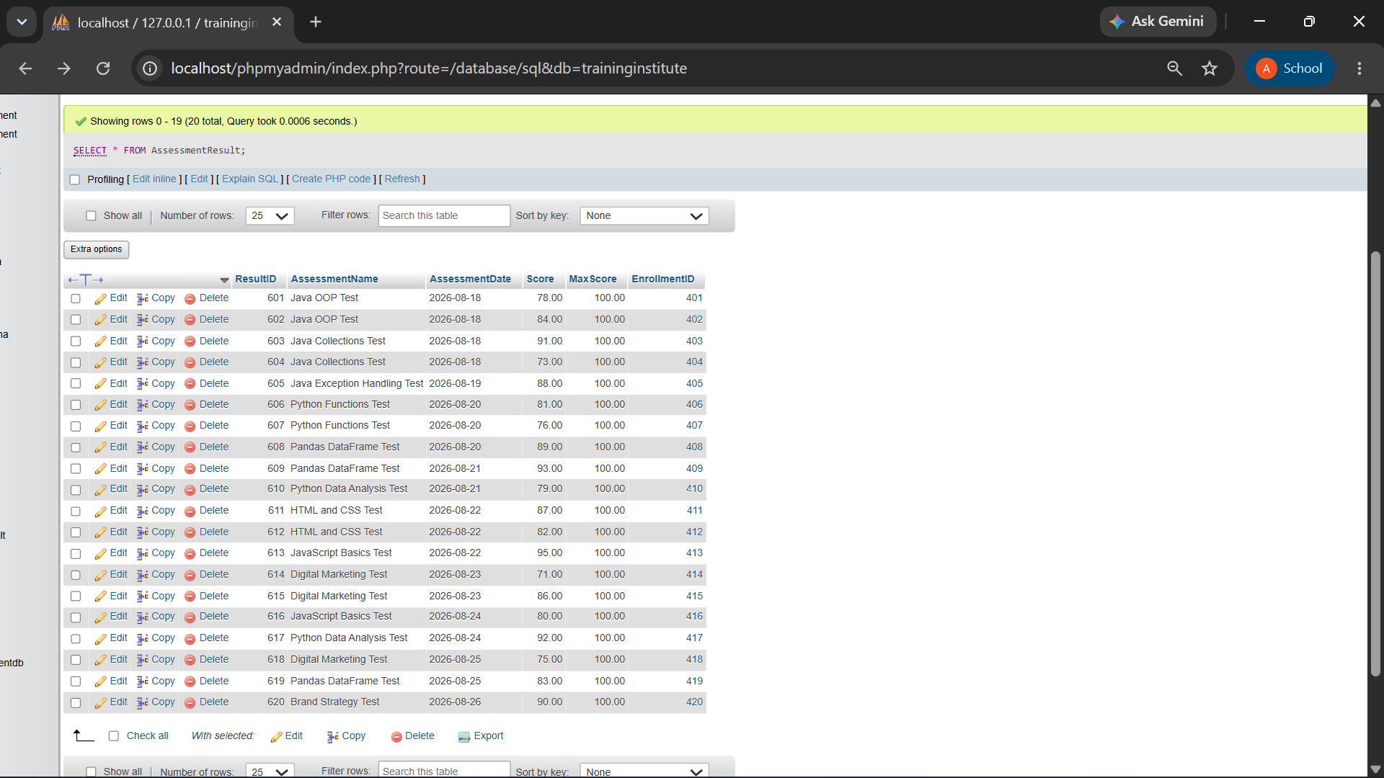

Verification of data and foreign keys
Student | Trainer | Course | Batch | Enrollment | Attendance | AssessmentResult
15 | 4 | 4 | 6 | 20 | 20 | 20

11. Business Queries and Data Analysis
Q1. Display all students enrolled in each batch.
SELECT
B.BatchName,
S.StudentName,
S.StudentID
FROM Enrollment E
INNER JOIN Student S ON E.StudentID = S.StudentID
INNER JOIN Batch B ON E.BatchID = B.BatchID
ORDER BY B.BatchName, S.StudentName;

Output:
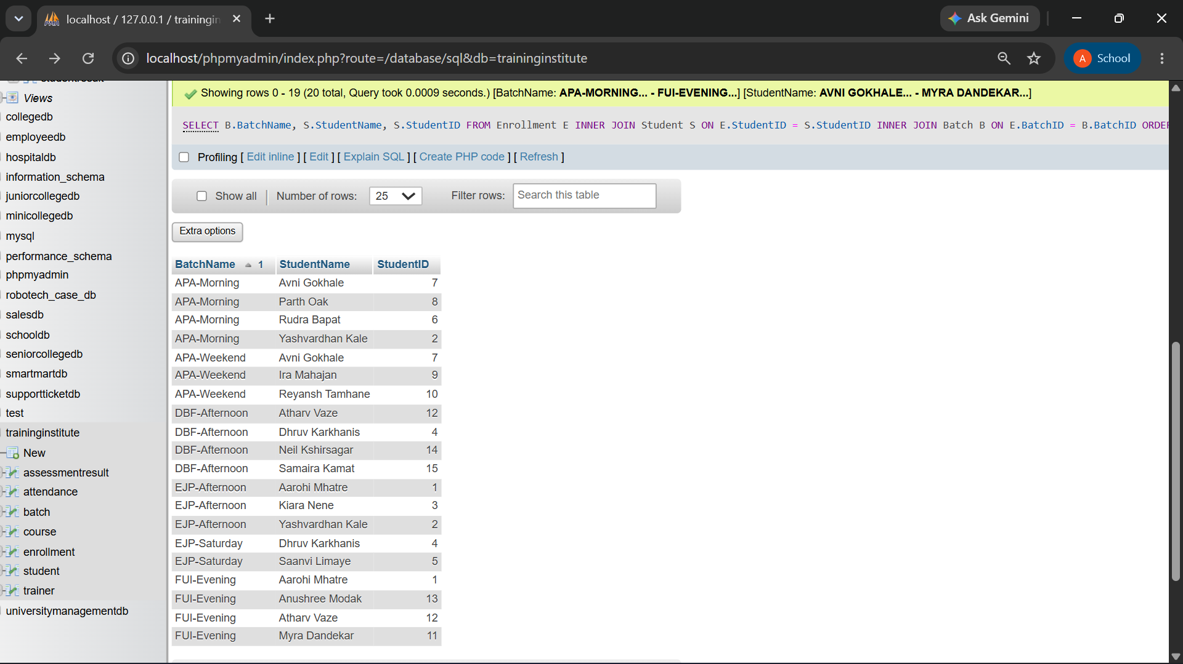

Result: 20 enrollments were recorded across 6 batches. Five students appear in two different batches, while the remaining students appear in one batch only.

Q2. Display the course and trainer assigned to every batch.
SELECT
B.BatchName,
C.CourseName,
T.TrainerName,
B.Timing
FROM Batch B
INNER JOIN Course C ON B.CourseID = C.CourseID
INNER JOIN Trainer T ON B.TrainerID = T.TrainerID;

Output:
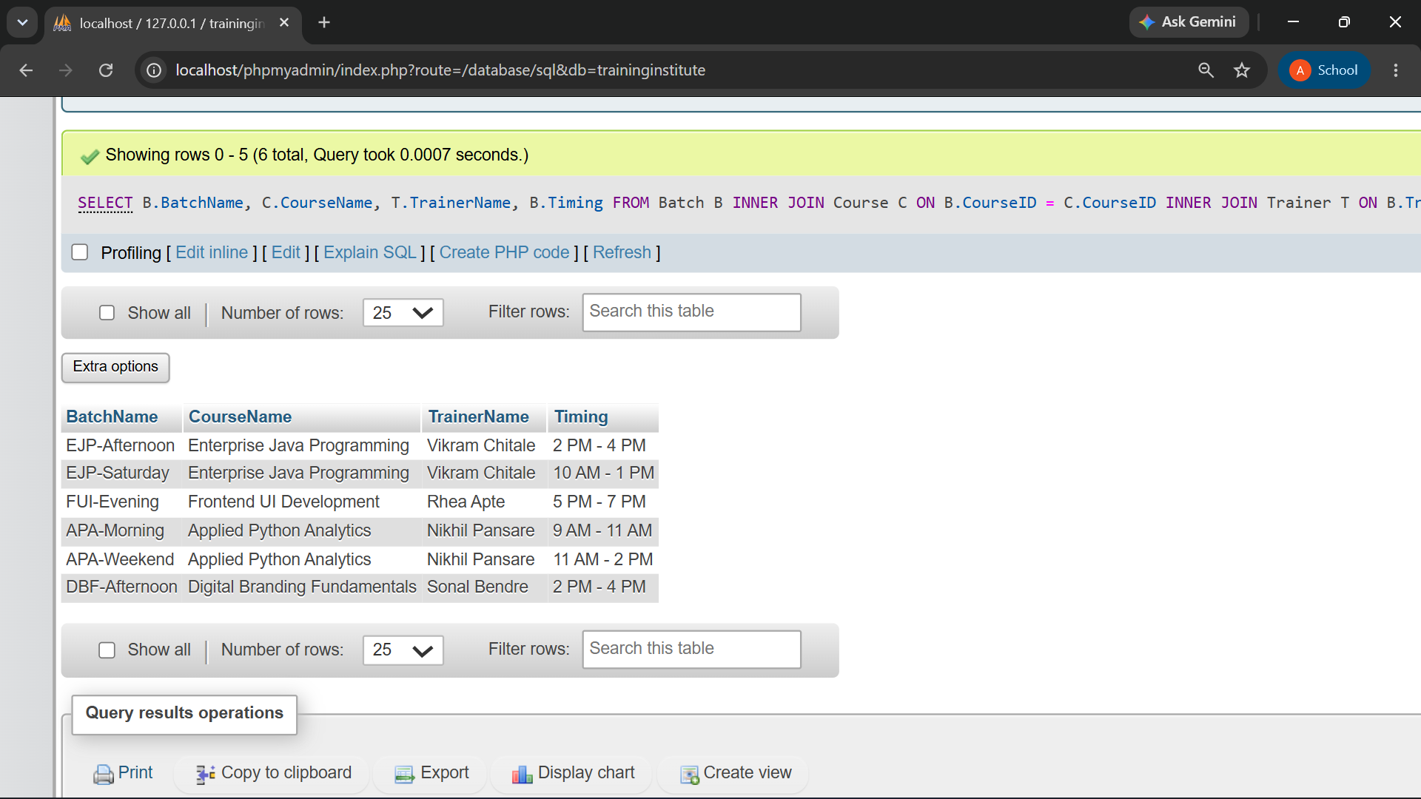
Result: Vikram Chitale handles both Java batches, while Nikhil Pansare handles both Python batches. Rhea Apte and Sonal Bendre handle one batch each.

Q3. Find the total number of students in each course.
SELECT
C.CourseName,
COUNT(DISTINCT e.StudentID) AS TotalStudents
FROM Course C
LEFT JOIN Batch B ON C.CourseID = B.CourseID
LEFT JOIN Enrollment E ON B.BatchID = E.BatchID
GROUP BY C.CourseID, C.CourseName;
Output:
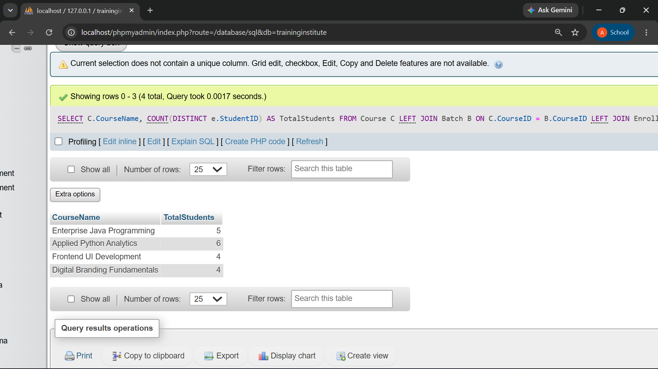

Result: Applied Python Analytics has the highest number of students with 6, followed by Enterprise Java Programming with 5, while Frontend UI Development and Digital Branding Fundamentals have 4 students each.. COUNT(DISTINCT) avoids double counting a student in two batches.

Q4. Find batches having more than 2 students.
SELECT
B.BatchName,
COUNT(E.EnrollmentID) AS TotalStudents FROM Batch B
LEFT JOIN Enrollment E ON B.BatchID = E.BatchID
GROUP BY B.BatchID, B.BatchName
HAVING COUNT(E.EnrollmentID) > 2;

Output:
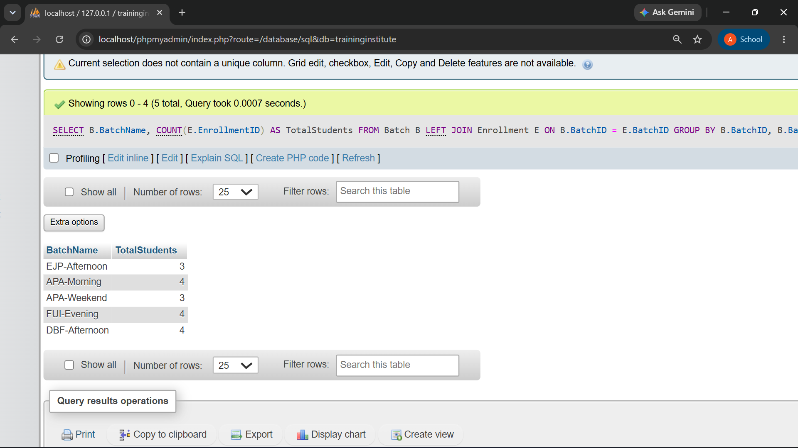
Result: Five batches qualify; APA-Morning, FUI-Evening, and DBF-Afternoon have the highest enrollments with 4 students each, followed by EJP-Afternoon and APA-Weekend with 3 students each.

Q5. Display students whose attendance is below 75%.
SELECT S.StudentName, B.BatchName,
ROUND(100 * SUM(A.Status = 'Present') / COUNT(*), 2) AS ATTENDANCEPERCENT
FROM Attendance A
JOIN Enrollment E ON A.EnrollmentID = E.EnrollmentID
JOIN Student S ON E.StudentID = S.StudentID
JOIN Batch B ON E.BatchID = B.BatchID
GROUP BY E.EnrollmentID, S.StudentName, B.BatchName
HAVING ATTENDANCEPERCENT < 75
ORDER BY ATTENDANCEPERCENT;
Output:
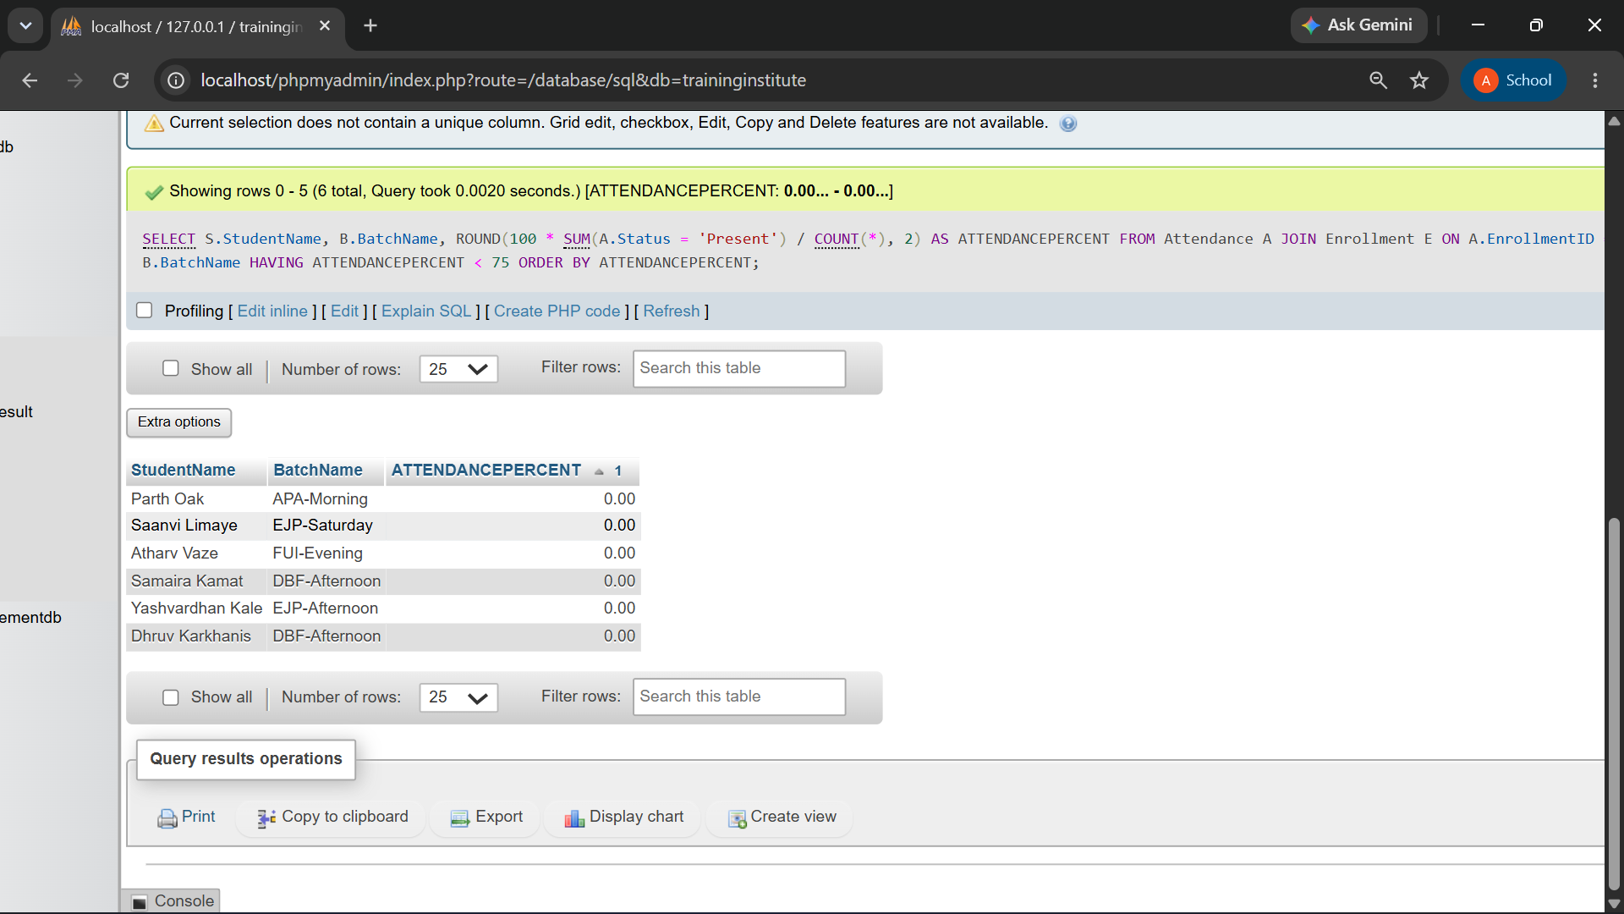
Result: Six students have attendance below 75%, and all six have 0% attendance based on the available attendance records.

Q6. Find the average assessment score for each batch.

SELECT B.BatchName, ROUND(AVG(R.Score), 2) AS AVGSCORE
FROM AssessmentResult R
JOIN Enrollment E ON R.EnrollmentID = E.EnrollmentID
JOIN Batch B ON E.BatchID = B.BatchID
GROUP BY B.BatchID, B.BatchName
ORDER BY AVGSCORE DESC;
Output:
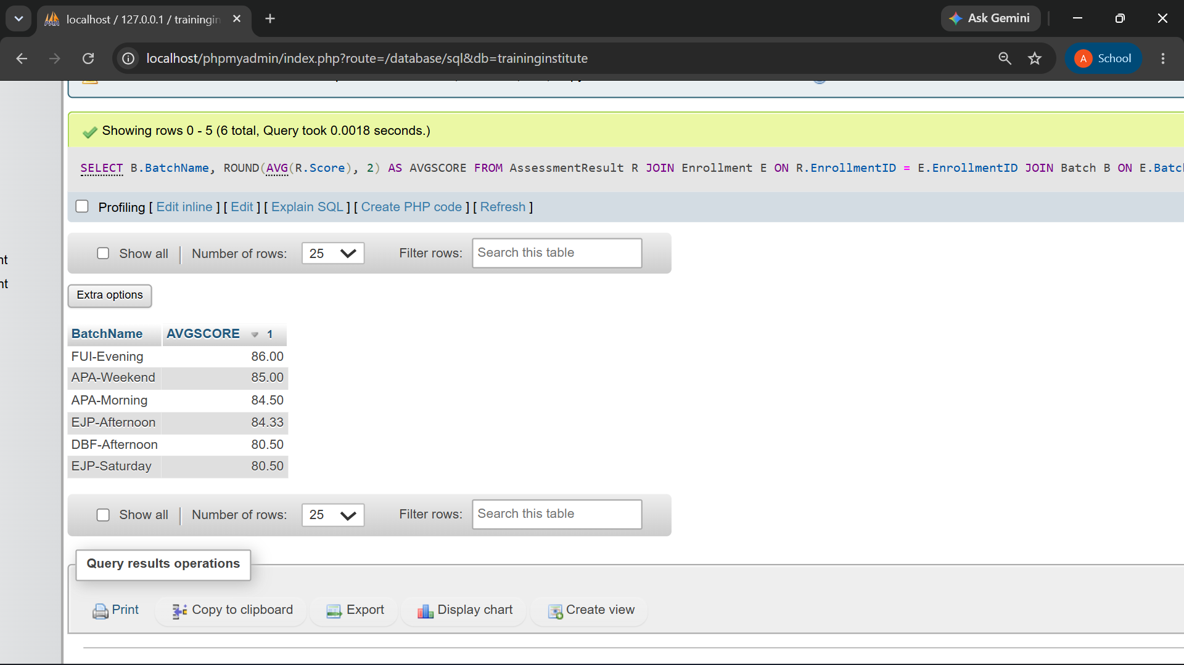
Result: FUI-Evening has the highest average score of 86.00, while EJP-Saturday and DBF-Afternoon have the lowest average score of 80.50.

Q7. Identify the highest-performing student in every batch.
SELECT
BatchName, StudentName, Score
FROM (
SELECT
B.BatchName, S.StudentName, A.Score, ROW_NUMBER() OVER (
PARTITION BY B.BatchID
ORDER BY A.Score DESC, S.StudentID
) AS RowNum
FROM AssessmentResult A
INNER JOIN Enrollment E ON A.EnrollmentID = E.EnrollmentID INNER JOIN Student S ON E.StudentID = S.StudentID
INNER JOIN Batch B ON E.BatchID = B.BatchID
) AS RankedStudents WHERE RowNum = 1;

Output:
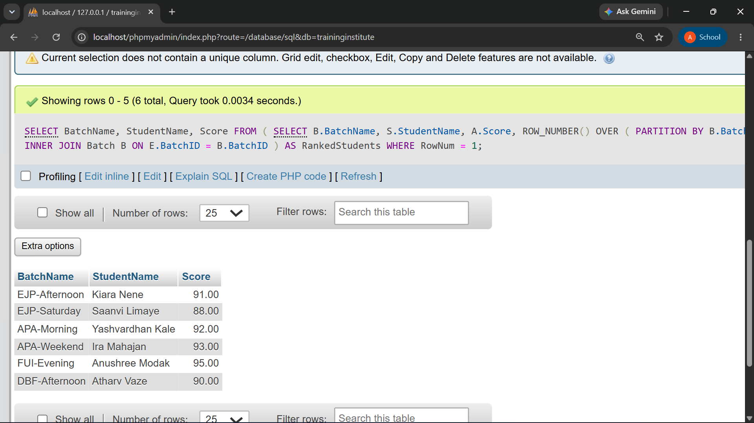
Result: Every batch has one topper; RANK() would show both if two students tied.
Q8. Display students who have not attended any session.
SELECT
S.StudentID, S.StudentName
FROM Student S WHERE NOT EXISTS (
SELECT 1
FROM Enrollment E INNER JOIN Attendance A
ON E.EnrollmentID = A.EnrollmentID WHERE E.StudentID = S.StudentID
);

Output:
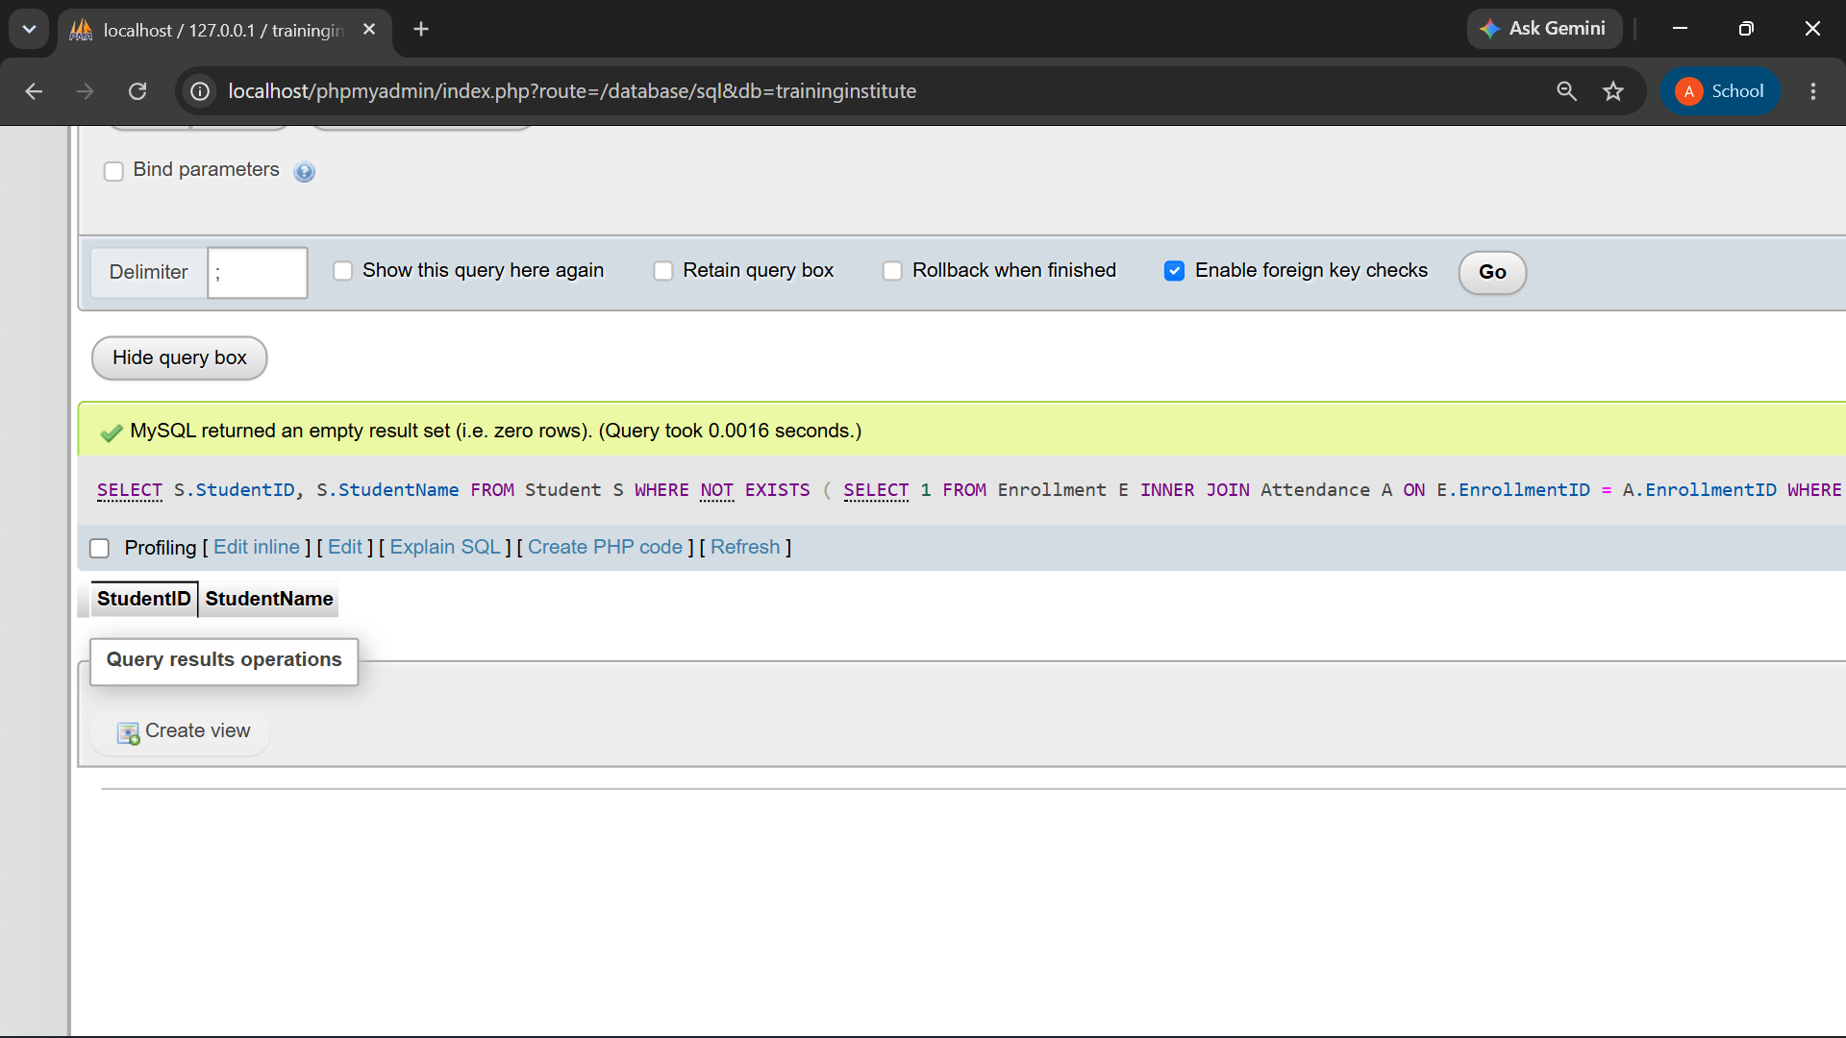
Result: The query returned zero rows. All 15 students have at least one attendance record linked to an enrollment, so no student is completely missing a session record in this dataset.
Q9. Compare course-wise student performance.
SELECT
C.CourseName,
COUNT(DISTINCT E.StudentID) AS TotalStudents,
ROUND(AVG(A.Score), 2) AS AverageScore,
MAX(A.Score) AS HighestScore,
MIN(A.Score) AS LowestScore

FROM Course C

LEFT JOIN Batch B ON C.CourseID = B.CourseID
LEFT JOIN Enrollment E ON B.BatchID = E.BatchID
LEFT JOIN AssessmentResult A ON E.EnrollmentID = A.EnrollmentID

GROUP BY C.CourseID, C.CourseName;

Output:
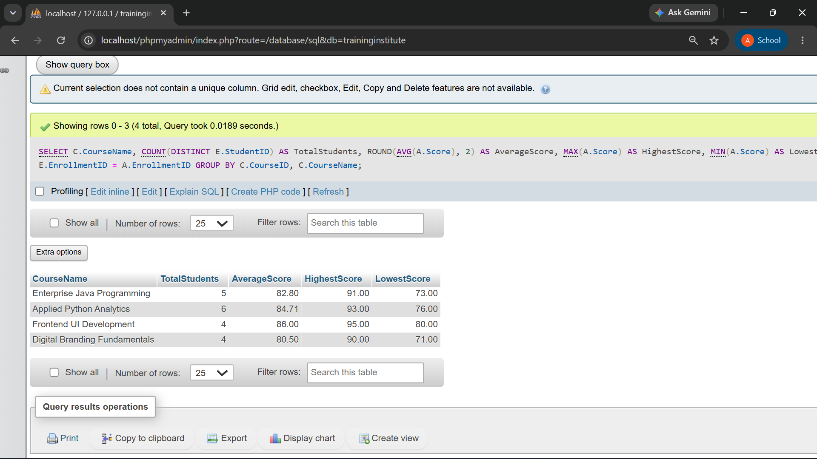

Result: Frontend UI Development has the highest average score (86.00, 4 students); Digital Branding Fundamentals is the lowest (80.50). Applied Python Analytics has the most students enrolled (6).
Q10. Rank students according to assessment results.

SELECT
S.StudentName, B.BatchName, A.Score, RANK() OVER (
ORDER BY A.Score DESC
) AS OverallRank FROM AssessmentResult A
INNER JOIN Enrollment E ON A.EnrollmentID = E.EnrollmentID
INNER JOIN Student S ON E.StudentID = S.StudentID
INNER JOIN Batch B ON E.BatchID = B.BatchID;

Output:
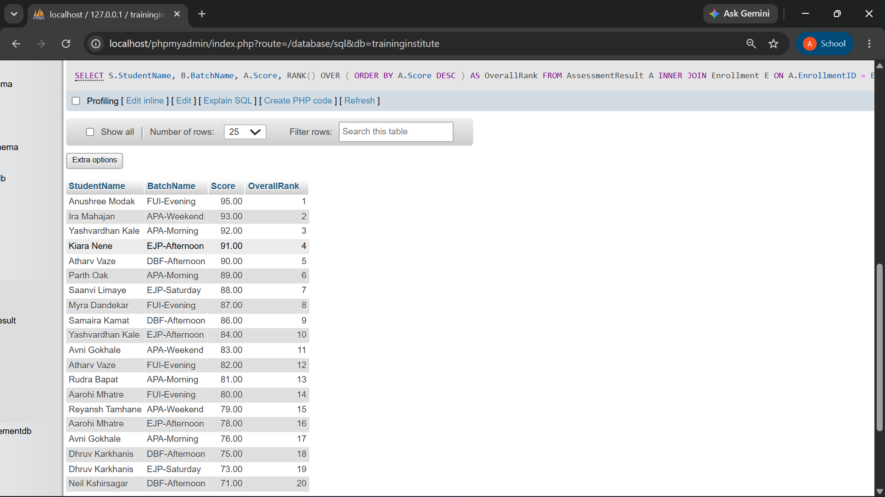

Result: Anushree Modak (FUI-Evening) ranks first with 95.00; Neil Kshirsagar (DBF-Afternoon) ranks last at 20th with 71.00. All 20 scores are distinct, so no ties occur in this dataset.
Q11. Find batches with the highest and lowest average attendance.
SELECT
B.BatchName, ROUND(
100.0 * SUM(A.Status = 'Present') / COUNT(A.AttendanceID), 2
) AS AttendancePercentage FROM Batch B
INNER JOIN Enrollment E ON B.BatchID = E.BatchID
INNER JOIN Attendance A ON E.EnrollmentID = A.EnrollmentID
GROUP BY B.BatchID, B.BatchName
ORDER BY AttendancePercentage DESC;

Output:
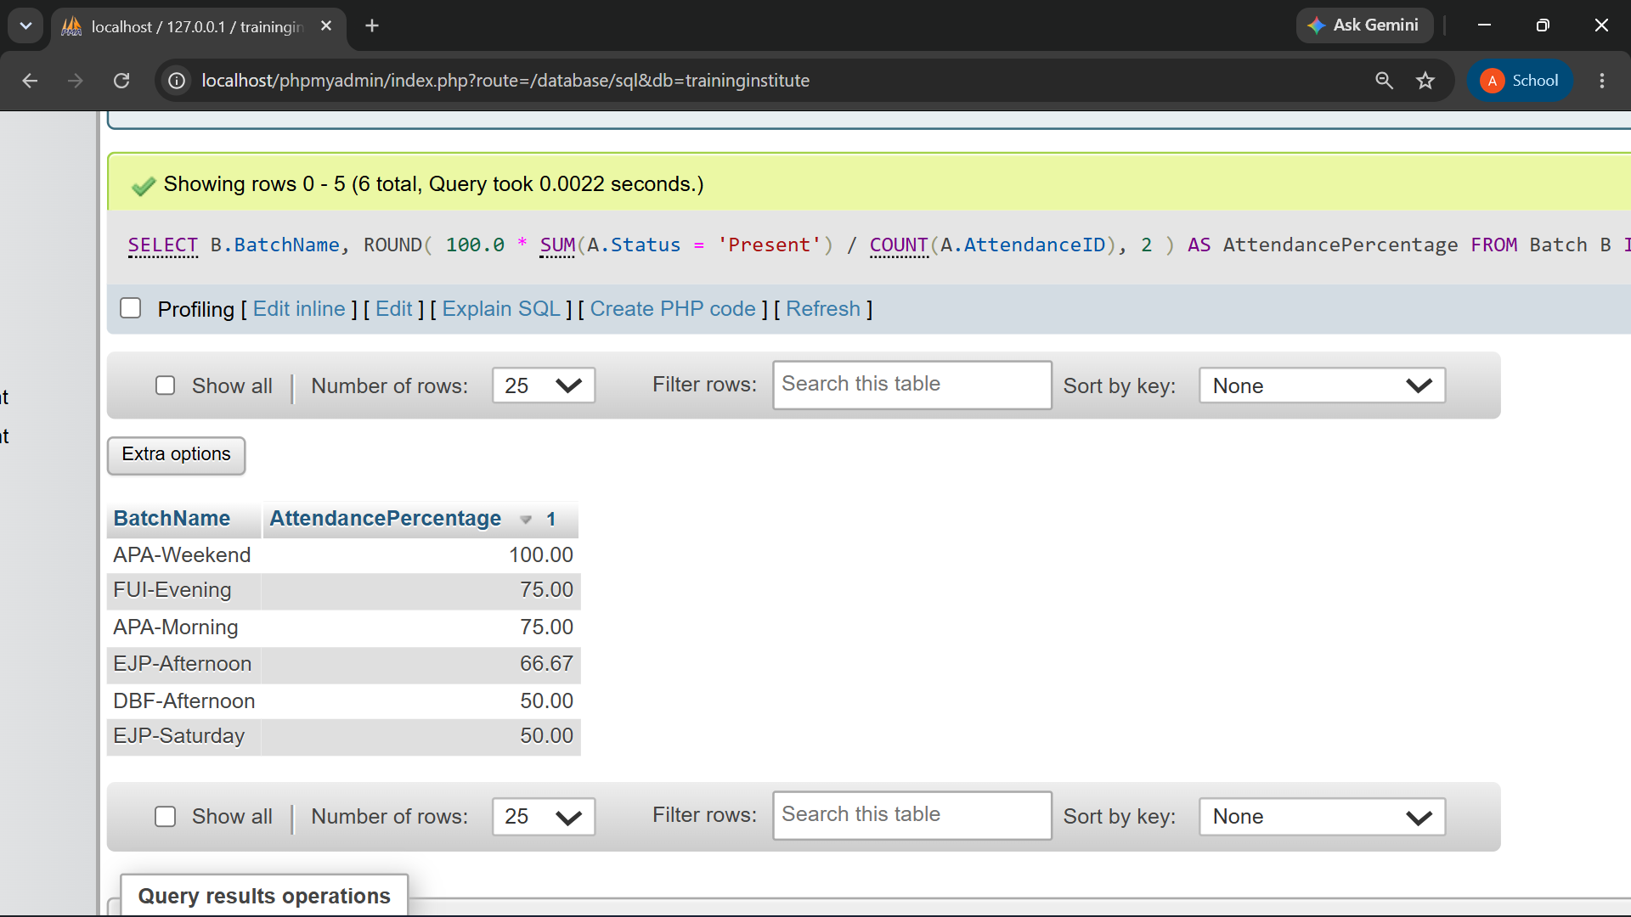
Result: APA-Weekend has the highest attendance (100%); DBF-Afternoon and EJP-Saturday tie for the lowest (50%).

Q12. Generate a student-wise training progress report.

SELECT
S.StudentName, C.CourseName, B.BatchName, ROUND(
100.0 * SUM(A.Status = 'Present') / COUNT(A.AttendanceID), 2
) AS AttendancePercentage,
ROUND(AVG(R.Score), 2) AS AverageAssessmentScore FROM Student S
INNER JOIN Enrollment E ON S.StudentID = E.StudentID INNER JOIN Batch B ON E.BatchID = B.BatchID
INNER JOIN Course C ON B.CourseID = C.CourseID
LEFT JOIN Attendance A ON E.EnrollmentID = A.EnrollmentID
LEFT JOIN AssessmentResult R ON E.EnrollmentID = R.EnrollmentID GROUP BY S.StudentID, S.StudentName, C.CourseName, B.BatchName;

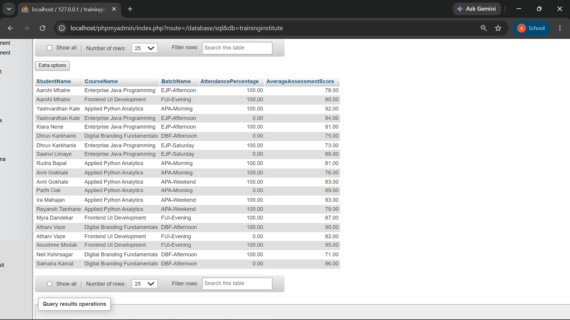
Result: The report lists all 20 enrollments with attendance percentage and assessment score side by side. Several rows show 0% attendance alongside a recorded score (for example Yashvardhan Kale, EJP-Afternoon, 84.00) — the data-quality gap discussed in section 13.

12.Useful View for Management Reporting

CREATE VIEW StudentProgressView AS SELECT
S.StudentID, S.StudentName, C.CourseName,
B.BatchName, ROUND(
100.0 * SUM(A.Status = 'Present') / COUNT(A.AttendanceID), 2
)
AS AttendancePercentage,
ROUND(AVG(R.Score), 2) AS AverageAssessmentScore FROM Student S
INNER JOIN Enrollment E ON S.StudentID = E.StudentID INNER JOIN Batch B ON E.BatchID = B.BatchID
INNER JOIN Course C ON B.CourseID = C.CourseID
LEFT JOIN Attendance A ON E.EnrollmentID = A.EnrollmentID
LEFT JOIN AssessmentResult R ON E.EnrollmentID = R.EnrollmentID GROUP BY S.StudentID, S.StudentName, C.CourseName, B.BatchName;

SELECT * FROM StudentProgressView;

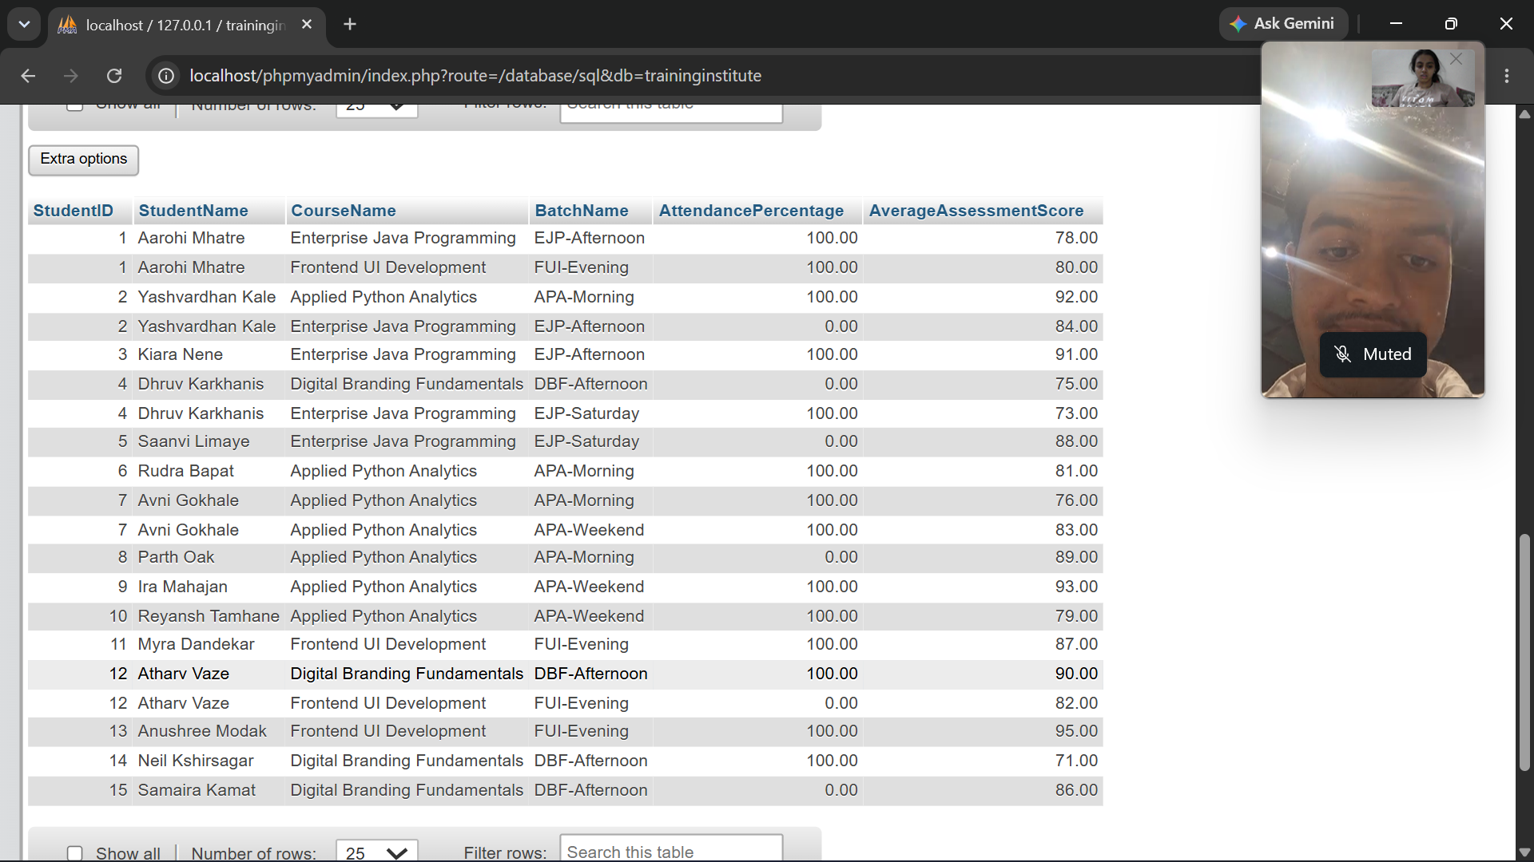
The view provides a reusable student progress report without rewriting the complete join and aggregation query.
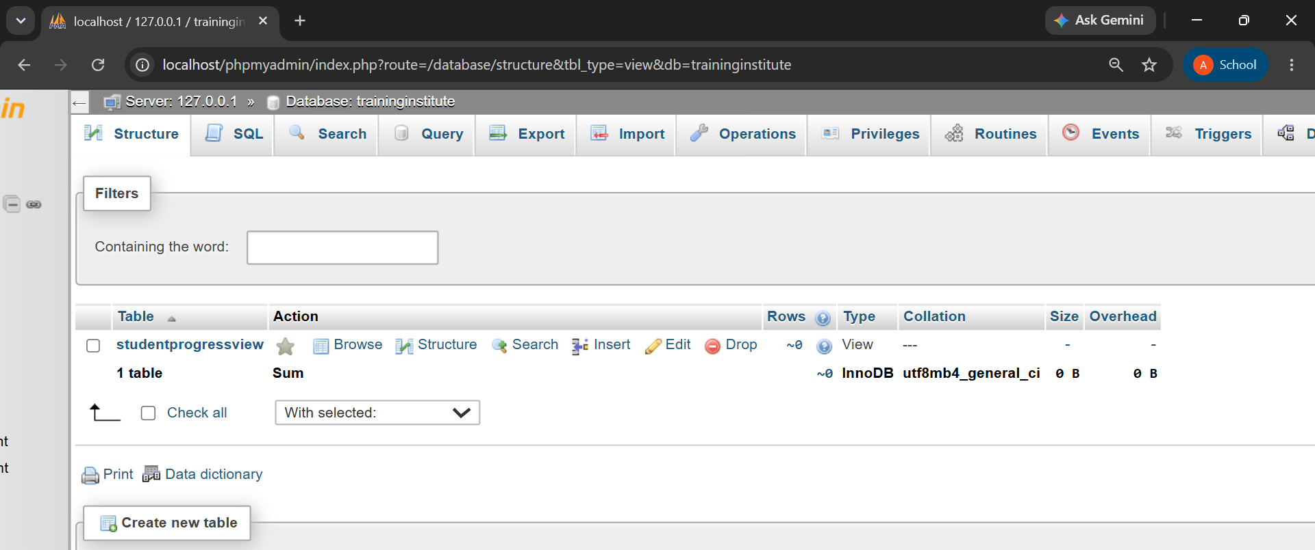

13. Analysis from the Sample Data
Analysis Area | Finding
Course enrollment | Applied Python Analytics has the most students (6, with 7 enrollments); Enterprise Java Programming has 5; Frontend UI Development and Digital Branding Fundamentals have 4 each.
Low attendance | Six enrollments have 0% attendance (each enrollment has only one recorded session, so attendance is either 0% or 100%): Parth Oak (APA-Morning), Saanvi Limaye (EJP-Saturday), Atharv Vaze (FUI-Evening), Samaira Kamat (DBF-Afternoon), Yashvardhan Kale (EJP-Afternoon) and Dhruv Karkhanis (DBF-Afternoon).
Batch performance | FUI-Evening has the best average score (86.00) and EJP-Saturday and DBF-Afternoon tie for the lowest (80.50).
Attendance by batch | APA-Weekend has 100% attendance; DBF-Afternoon and EJP-Saturday tie for the lowest at 50%. Overall attendance is 70% (14 of 20 sessions).
High performers | Anushree Modak (95.00, FUI-Evening) leads the overall ranking; Ira Mahajan scores 93.00 in APA-Weekend.
Weak batch | EJP-Saturday and DBF-Afternoon are the weakest batches: both tie for the lowest average score (80.50) and the lowest attendance (50%), so they need the most attention.
Data quality | Six enrollments show a recorded assessment score even though attendance was 0% for that session (for example Yashvardhan Kale scored 84.00 in EJP-Afternoon despite 0% attendance), so results should be validated against attendance before being accepted.

14. How the Institute Can Use the Results
- Use course and batch counts to see demand and plan new batches.
- Use attendance percentages to follow up with students below 75%.
- Use average scores and rankings to find strong students and those who need support.
- Use trainer and batch data to balance workload (Nikhil Pansare handles 6 students across 2 batches; Rhea Apte and Sonal Bendre handle 4 students each on a single batch).
- Review weak batches such as EJP-Saturday and DBF-Afternoon and repeat what works in APA-Weekend and FUI-Evening.

15. Required SQL Techniques Demonstrated
Technique | Use in this Project
Joins | INNER and LEFT JOIN connect all seven tables.
Aggregate functions | COUNT(), AVG(), MAX(), MIN() and SUM() summarize enrollments, scores and attendance.
Grouping and HAVING | Batch size (Q4) and attendance percentage (Q5).
Subqueries and CTEs | NOT EXISTS (Q8) and WITH clauses (Q7, Q11).
Window functions | RANK() and DENSE_RANK() for toppers and student ranking.
Constraints | PRIMARY KEY, FOREIGN KEY, NOT NULL, UNIQUE and CHECK protect the data.

16. Conclusion
The Training Institute Management System gives a clean relational database for students, trainers, courses, batches, enrollments, attendance and assessment results. Seven tables, six one-to-many relationships and the associative entity Enrollment keep the data free of repetition, and constraints make sure every record links to a valid record. All twelve business queries were run and the results show where the institute should act: weak attendance, two weak batches (EJP-Saturday and DBF-Afternoon) and uneven trainer workload.

17. Submission Checklist
☑ ER diagram showing all seven required tables, relationships and the associative entity Enrollment.
☑ Primary key for every table.
☑ Foreign keys for all required relationships.
☑ MySQL database and table creation script.
☑ Realistic sample data in all tables.
☑ All twelve business queries with output.
☑ Analysis, insights and conclusion.
☑ Separate MySQL script file (training_institute.sql) included with this report.

